The Impact of Covid19 Pandemic toward the Livelihood of
Vast Growing of Elderly in Indonesia
Sri Hartini Rachmad, MA & Eka Rumanitha, MA
Summary:
Inspired by Quality of Live Index, this paper aims to analyse and portray the impact of Covid-19 Pandemic towards the elderly livelihood in Indonesia. This is not only related to the fact that Indonesian is the fifth fastest growing country of elderly population, but also is aged group have made of 11.2 percent along with the same case contributed to the world cases, of 38.6 percent in 19 countries by late August 2020. As Covid-19 pandemic in particular brought significant consequences that changed the life of elderly in many ways, the fact that this age group are the most vulnerable for their health protection and lack of attention in compared to those productive and youngest age group. Three major indicators of basic livelihood thus are observed; healthy, happy and active or being able to participate in the social function. A significant disruption during this pandemic has been the changing income sources and other activities that has been disconnected due to some limitations for them. The elderly has been made up 28.5 percent of the total households in Indonesia, and they are now the head of the households of about 62.3 percent across Indonesia with various changes and activities respectively as the households have been in worsening condition. This study in specific therefore explores those changes regarding to the vast growth of elderly as the second wave of bonus demography consequences during the pandemic and its future path. They are vulnerable both for their health safety and social contribution with lack of protection. It is expected by identifying factors responsible for better livelihood for elderly, better policies at regional and elderly friendly systems to adapt for the future should be provided along with the access towards their social activities right across the country.
Keywords: Covid-19, Indonesia, elderly, QLI and Ageing Support programs

Introduction
As the world population experienced various development advancement in various sectors, the people hence now is getting older. The developing countries a demographic transition to its population growth, pace and ageing anticipation facilities. This vast growing elderly has been occurring almost in most countries and predicted to be faster in the middle income and developing countries. As stated, the total number of the elderly people will be double in size worldwide, from 12.0 percent to become 22.2 percent between the year of 2015 and 2050 respectively. World Health Organisation-WHO report highlighted that the time needed to grow the size of elderly in various country varied. For example, France took 150 years to grow their elderly from 10.0 percent to 20.0 percent by 2015, while for Brazil China and India only need 20 years. In consequence, in China alone there will be 120 millions elderly by 2050. The development condition and demographic history of France and other example’s countries are different. Therefore, the current Covid-19 pandemic attack hence attracts serious attention for the elderly since they mostly living in the variety of life quality and health support. As it shown in Picture 1 below, it is confirmed that Covid-19 cases increased in percentage along with the older aged group. This is the confirmed Covid-19 fatality victims towards the aged group in China during the first three months of 2020. The risks health factors towards the aged groups for Chinese community have been a serious and deadly. It ranged from 0.2 - 0.4 percent for the aged group less than 49 years old, compared to range of 1.3 percent – 14.8 percent.

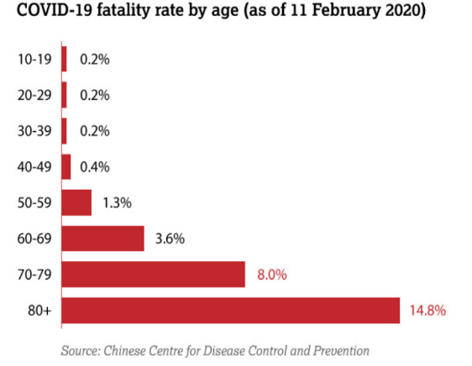

Picture 1. Fatality rate of Covid 19 by aged groups, China

In particular, it stated that “COVID-19 presents specific risks for older people. Initial research in China based on over 44,000 cases of COVID-19, showed a mortality rate of 2.3 per cent for the general population, rising to 8 per cent in those aged 70-79 and nearly 15 per cent in those 80 and over”. The above picture represent how Confirmed Covid-19 cases in China has become an alarming fact for other. It provided a serious lesson to rest of the countries in handling the cases during this Covid-19 pandemic. A similar pattern has also found and true for the confirmed cases in Indonesia. There has been a significant fact that since the first time the Covid-19 pandemic outburst by early 2020. The proportion of the people of aged 60+ years and above in Indonesia as reported to be around 9.8 percent in 2017 and expected to increase to become 13.7 percent and 20.3 percent in 2030 and by 2050. During the first year of pandemic in the world, there has been in Indonesia, “amongst of those the confirmed cases of COVID-19 in Indonesia, hypertension accounted for 50.5 percent, diabetes 34.5 percent, and cardiovascular disease 19.9 percent.
This is why older people are considered the most affected group during this pandemic”. In Indonesia as the elderly living mostly with their families, as stated in the report though, “There is, however, little evidence to suggest that older people today are experiencing their later years in better health than their parents. While rates of severe disability have declined in high-income countries over the past 30 years, there has been no significant change in mild to moderate disability over the same period”.
This paper in particular therefore focuses on how the impacts of covid-19 pandemic towards the livelihood or decent living condition of the elderly in Indonesia. The living condition observed here is based on the Quality life Index that here is defined as the changes of basic essential different aspects of living in seven types of countable-measure indexes such as; purchasing power index, safety index, Health care index, climate index, cost of living index, traffic Commute Time Index, Pollution Index and property price to income ratio. This Quality life index, gave the users an understanding the detail components of decent living between areas.
The data sources used for the proposed objectives above is the results of Population Census 2020 and its relevant findings. There are other related reports on covid and aging in Indonesia also use to explain the changes. The use of the Quality Life Index in particular used to portray the case in global perspective. The interesting expectation to see as we can identify how elderly has experienced a scatter shot of different level of facilities and access to health facilities and protections. How the above basic living condition has changed during crisis, further been added in the specific findings of this study on covid-19 and the growing elderly in Indonesia.

Rapid growth of elderly and Covid19 pandemic task force
The Covid19 pandemic that started from city of Wuhan, China by the end of year 2019 has aggressively spread-out and changed the world’s normal livelihood. All of normal practices of human activities hence adjusted even stopped. The elderly in particularly were the one on the red zone and shifted to work from a normal office way to be at work from home mode. They are the people belong to senior aged group of 60+ years and above population. As regulated globally, the elderly group is the one that has the less strong immune system and most high-risk individuals. This covid19 pandemic in specific has challenged a personal immunity and health issues. Happiness and freedom to be at the crowd and be with your friends and group has not anymore feasible.
This aged groups have not only added up in size to be massive aged society due to the bonus demographic timing, as the birth rate has been steadily declining. There has been also in line with current advancement of healthy life style and low level of death rates for quite some time. The change has been an alarming fact since there has been less attention are preparing for this new reality. First in keeping the aged group in a stabile livelihood condition. Second is about the support system that should be there as they disengaged from workforce. The advancement on various human quality life, there has been a remarkable high rate of productive aged group during the two decades ago, whom will soon be entering the second wave of aging population. The pandemic posts not only physical limitation for the aged group but also emotional as they are the one guarded by rule to stay home and adjust their working routine in most areas.
As the development outcomes produced advancement for numerous factors, it does in particular breed society to live longer. Around the world, there has been growing numbers of ageing population including across the ASEAN countries. The Figure 2. clearly shows that the future is world predicted to be rapidly filled in with aging population. In ASEAN countries as identified the leading countries has been Korea and Japan. How detail these two countries have prepared towards their aging communities will be the sources to observed particularly on the health-related facilities.
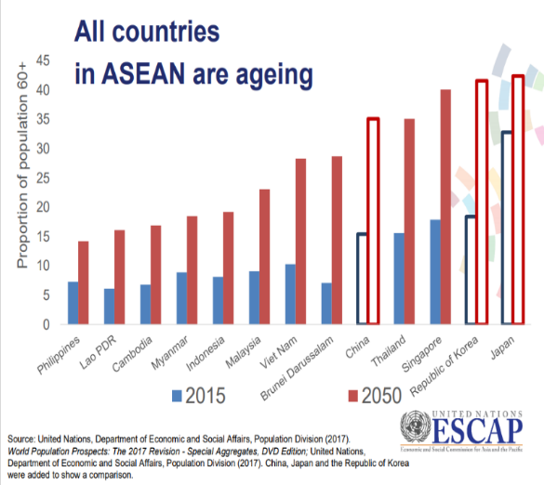

Figure 1. Ageing in all ASEAN countries in compared to Korea and Japan, 2015

Covid-19, as the vast spreading virus infected most active people and, in many regions, and cities at uncontrollable level. The cases of confirmed C19 by age in Indonesia for the first six months has been rocketing and even attacking so many people at all aged. Data on covid by aged group for Indonesia remain scatter as the confirmed cased remain continue.
In a very short time this pandemic successfully made most of the authorities not only stopped various socio-economic activities but work immensely long hours to find ways and solution to manage the cases. In particular, the most affected group to be priority on list are the elderlies. They are on hold from most of their activities and requested to work from home-based. Further, the prolong condition has also been triggering other diseases till a time-less period. Some countries even now experienced the third wave and continue to stopped and turned off their economic as the covid virus. In Indonesia, the rapid growth of the Ageing population predicted to be of 19.9 million by the year 2045. This the size will be one fifth of the total population.
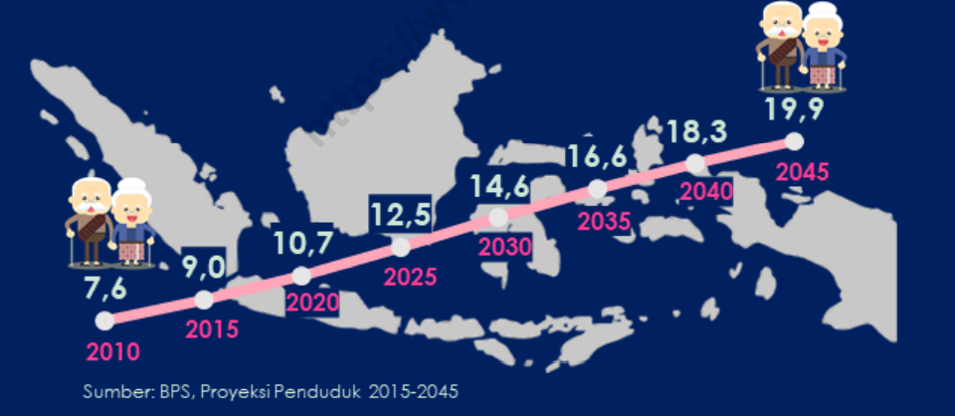

Impact for the Elderly - Interesting Findings
One basic reason has been put forward to protect the elderly is that their life span is in a declining process on the average scale. The engagement of this group from various protection of health and work-related supports to some made they become most vulnerable for the attacking of Covid19 pandemic. Although many remain very much active even till the age of 75 years old, the significant highlight that attracts attention during this pandemic was the fact that they the one of whom most vulnerable group of all. Not only due to health problems as they aged condition, but they awareness of some has also weaking even none. The family has indeed their closest support they might relies on. While in compared to the other two groups; the youngest and productive age group the support and the health coverage are still on program. Thus, covid19 pandemic to this group of population has brought about a down-side pressure as many have been living with various health issues; hypertension, diabetes, cancer, breathing problems as the results of unhealthy life style. This is one the essential reason of why some regulations that focusing more on the elderly of those 60 + years old and above, and keeping these age groups stay home and be safe from the normal interaction activities from the normal practice.
The cases of confirmed Covid 19 for elderly in Indonesia can be classified onto three different issues : type of the households the elderly belong to

Arguments on
For example, the Quality-of-Life Index- QLI that can represent the socio-economic condition of living in two cities, Jakarta and Tokyo is significantly different, of 158,0 point for Tokyo and 68.34 point for Jakarta, as can be seen on the Table 1. The table shows that the health-related indexes in Jakarta are way to low in compared to that of in Tokyo City, Japan. It is in live with the low cost of living that Jakarta shows in general. The Pollution index in contrast is also found to be very high in Jakarta. Tokyo has a moderate level along with its traffic commute time to work that can also influence the working and health issues for the people in these two cities.
Table1. Quality Life Index Comparation of Tokyo and Jakarta, 2021
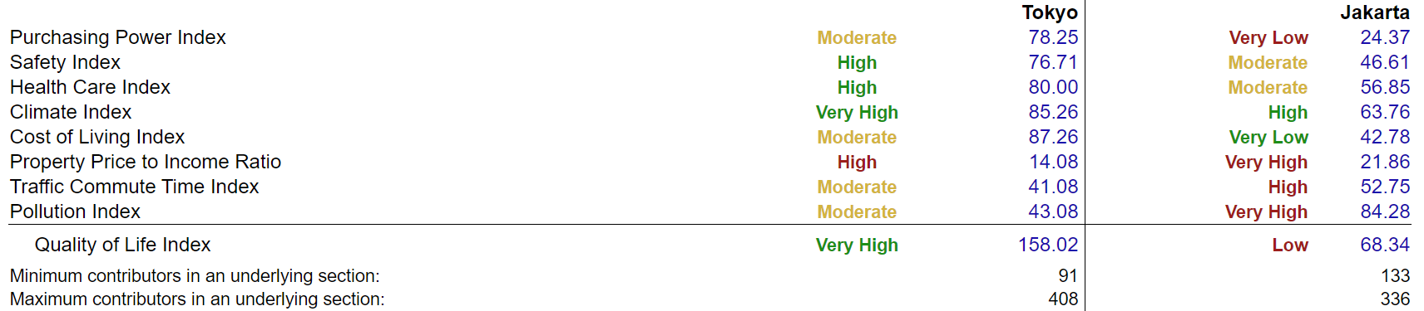

Researcher at BPS Statistics Indonesia, address: BPS National office, Jl Doktor Sutomo no.6-8 Pasar Baroe, Jakarta Pusat, Indonesia-10710, email : shrachmat2@gmail.com
Lecturer and social -economic researcher at Polytechnique STIS – Indonesia , address: STIS , Jl. Otista No 64/C, Jakarta Timur – 13330, Indonesia, email: eka.rumanitha@stis.ac.id
Human Development Report 2020 (online)
BPS – Statistics Indonesia: Elderly is the people aged 60+ years old and above.
Eria.org – Older people and Covid in Indonesia
BPS- “Statistik Penduduk Lanjut Usia, - Statistics for Elderly People, 2020.
WHO 2018. Ageing and health (who.int). February 2018.
World Health Organization Website.
Http:/Agingasia.org.
World Health Organization – Elderly -abused. www -who.international.org. 15 June 2020.
Quality of Live Index that created by OECD 2011, Quality of Life Index – representing the accumulative of other various indices.
Who and Covid,
WHO covid
UNWPA report, 2019
UNESCAP, 2015 from ageing conference. UNESCAP web.
The covid19 UN Center, 2021; countries such as India and Thailand are the examples of the current Covid19 condition.
Numbeo. “Quality of Life Comparison Between Tokyo and Jakarta.” Quality of Life Comparison Between Tokyo, Japan And Jakarta, Indonesia, May 2021. https://www.numbeo.com/quality-of-life/compare_cities.jsp?country1=Japan&country2=Indonesia&city1=Tokyo&city2=Jakarta.
Findings and possible solutions There are four main major findings can be underline towards the elderly in Indonesia. These categories can be refer to the seven indexes that highlighted above. The noised that has been attacking each of the following will be diminishing their livelihood differently. The purchasing power index, safety index, Health care index, climate index, cost of living index, traffic Commute Time Index, Pollution Index and property price to income ratio. This Quality life index, gave the users an understanding the detail components of decent living between areas. These are all varies and very much related to the status and working experienced they have. First declining access to their income and the support system they belong to will ease the covid pandemic they have been facing. There has been no doubt that Covid 19 has been severely impacting the elderly over the past year of 2020. The pandemic has proved to are the group of population aged 60+ years and above of whom experience serious impact due to this Corona Virus Infectious disease2019 -C19. The pandemic that specifically attack the person with comorbid and with health issues as that of this aged group society. Conclusion The increasing size and percentage of older people in Indonesia should be put high concerned on how their livelihood can be managed and sustained. This study has found that specific social security for older people has not been designed yet, particularly on Covid-19 disaster in Indonesia where the targeting social assistance hasn’t been segregated by age group on elderly and mostly on household’s head basis. The remoting condition and regulation during pandemic all activities been shifted in specific place and less mobile and even ‘no go no where’ in terms of anticipating the spread of Covid-19, suggested to be mobile phone services available to all community level in order accessing the help regarding their specific needs. Policy regulation for nurturing socio-economic functions for older people in Indonesia should be developed, and during disaster period the enforcement should be on easier health services and assistances for them from anywhere. This should be initiated by in charged ministry of Health RI. If there will be possibility, the special couching on how to prevent the Covid-19 attack on individual should be provided in both On line and off line aimed consultation and first aid for the needs. References: International Labour Organization. 2018. World Social Protection Report 2017–19. Geneva ILO. Pension Watch. 2016. Country Fact File: Indonesia. [Online] Available at: http://www.pension-watch.net/pensions/country-fact-file/indonesia-[Accessed 5 August 2019] United Nations. 2017. Living Arrangements of Older Persons: A Report on an Expanded International Dataset. New York: United Nations. United Nations. 2019. World Population Prospects 2019. Retrieved from United Nations Population Division: https://population.un.org/wpp/Download/Standard/Population/ Short Bio of the writers Eka Rumanitha is a lecturer and research student adviser at Statistics Institute, Jakarta; on Social Demography and Applied Statistics at BPS Statistics Indonesia. She post graduated from University of Flinders – South Australia on Development and Social Studies 1997. She has teaching and working as lecturer since 2012. At the same time she works on Centre Studies for Statistical Social (2015), Working on UN –Indonesian team for on environment; and was BPS Statistic Indonesia staff (1988 – 2008).Her research subjects has been population and its socio economic changes. 1) Social analyst for statistical consistency on Education Year book, 2) Human Development and Poverty, 3) Representing the work for social and gender issues, 4)Lecturer on Poverty Course on UNSIAP – Poverty Measurement Training in Indonesia during 2006 & 2007. A lecturer on Women and Children as well as Education of Indonesia; Social Work with Ibero americana University – for International Event at Mexico Anahuac University - Mexico City. Some an example of research publications: Co Writer in Chapter of book titled Indonesia: Indonesia Disaster Preparedness-Springer UN University Publication, 2017; Empowering The Youth and Family Planning towards Gender Awareness Practice in Indonesia, TRS – BKKBN (2015); Household Poverty Criteria in Indonesia, BPS and UNDP (2005); Gender and Poor Female Headed Household in Jabodetabek Areas(2008); Women and Poverty : A Trickling down consequence of the Capital City. UNSIAP Research Base Training – paper. Daejeon (2007). Currently she published with team covid19 related issues on “role of religion’s leader towards the management of the Covid19 Pandemic in Indonesia,@http://journal.uinsgd.ac.id.Vol I-2021. Contact information: Email: eka.rumanitha@stis.ac.id Mobile Phone: +62(0) 813 9822 5410

