NBER

2012 Martin S. Feldstein Lecture

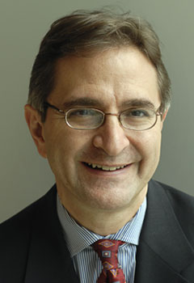

Steven N. Kaplan
Neubauer Family Distinguished Service Professor of
Entrepreneurship and Finance
University of Chicago Booth School of Business

Executive Compensation and Corporate Governance in the U.S.:
Perceptions, Facts and Challenges

Royal Sonesta Hotel – Ballroom B
July 10, 2012, 4:30 pm – 5:30 pm
followed by a reception from 5:30 pm to 6:15 pm

NBER

2013 Martin S. Feldstein Lecture

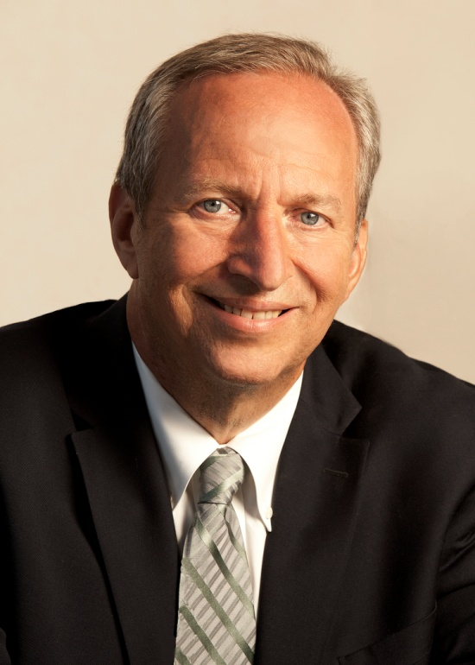

Lawrence Summers
Charles W. Eliot University Professor at Harvard University
Economic Possibilities for Our Children

Royal Sonesta Hotel – Ballroom B
July 24, 2013, 4:30 pm - 5:30 pm
Reception to follow from 5:30 pm to 6:15 pm

