I am in the process of finalizing book contract with Springer Publishing. During the fellowship at NBER, I plan to finish writing my book. The title of the book is “Corruption, Entrepreneurship, and Societal Welfare: Unsolved Puzzle”. This book sheds lights on the following questions---Is corruption an additional burden in extensive regulatory environment on different types of entrepreneurships---necessity entrepreneurship, opportunity entrepreneurship, total entrepreneurial activity, self-employment, international entrepreneurship, and newly registered firms? Is corruption helpful for entrepreneurs who have aspiration to operate outside their home country border in highly regulated environment? How does corruption affect income distribution and poverty reduction in society through entrepreneurial activity? This proposed research is in the intersection of corruption, entrepreneurship, and public policies (X in Figure1). The proposed research is a novel approach towards understanding the influence of human dimensions on entrepreneurship, economic growth and social welfare.
Figure 1: Proposed research at the intersection of corruption, entrepreneurship, and policies 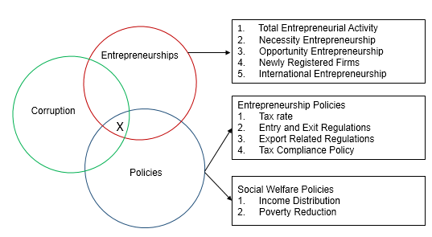
Income distribution varies widely across countries, the exact reason of which remains unclear and remains under investigation (Piketty, 2014). Equitable distribution of income is an important factor for maintaining a stable society and avoiding the erosion of “meritocratic values” in a country (Piketty, 2014, p1). Income inequality is an obstacle to economic growth and poverty reduction (de Ferranti et al. 2004), and access to education and health care facilities, leading to ‘inequality traps’ that can perpetuate across generations (World Development Report, 2006). To paraphrase Ferreira and Ravallion (2008, pp. 6), no country has successfully developed beyond middle-income status while retaining a very high level of income inequality. Political scientists and sociologists have researched income inequality in relations to economic development and causes of corruption.
Entrepreneurial activities are an important factor for local and national economies as they generate employment and income but there is variation in entrepreneurial activities across countries (Acs, 2006; Baumol, 1990; Djankov et al. 2002; Klapper et al. 2006; Hirschman, 1958; Hechavarria and Reynolds, 2009; Wennekers et al., 2005). Entrepreneurship may also lead to concentration of wealth in a handful of people, thus acting as a factor affecting income inequality.
A second factor that may contribute to the problem is corruption. Corruption is a common phenomenon in many developing countries, where individuals with financial resources are better able to extract resources for personal purposes at the expense of the larger society. An entrepreneur with resources and networks might be able to influence the regulatory agencies to overlook violations or expedite permit, or bribe corrupt program administrators to violate the rules of distribution (Piketty, 2014, Méon and Sekkat, 2005; Shleifer and Vishny, 1993). Therefore corruption may influence the distribution of wealth in society. Results from this part of the research will identify the factors that contribute to the reduction of income inequality in countries in which entrepreneurship has been increasing in lieu of corruption.
The importance of entrepreneurship to any economy has been recognized since the pioneering work of Joseph Schumpeter. This book provides an in-depth analysis of how corruption and regulations influence spillover effect of entrepreneurship on greater social welfare.
In the future, I plan to extend my research in the area of financial access and financial development.
References
Acs, Z. (2006). Start-ups and entry barriers: Small and medium-sized firms population dynamics. In: M. Casson, B. Yeung, A. Basu, and N. Wadeson eds. The Oxford handbook of entrepreneurship. Oxford: Oxford University Press, pp.194-224.
Baumol, W. J. (1990). Entrepreneurship: Productive, Unproductive, and Destructive. The Journal of Political Economy, 98(5 Part 1), 893-921.
De Ferranti, D. M. (Ed.). (2004). Inequality in Latin America: breaking with history? World Bank Publications.
Djankov, S., La Porta, R., Lopez-de-Silanes, F., & Shleifer, A. (2002). The regulation of entry. Quarterly journal of Economics, 1-37.
Ferreira, F. H., & Ravallion, M. (2008). Global poverty and inequality: a review of the evidence.
Hechavarria, D. M., & Reynolds, P. D. (2009). Cultural norms & business start-ups: the impact of national values on opportunity and necessity entrepreneurs. International Entrepreneurship and Management Journal, 5(4), 417-437.
Hirschman, A. (1958). The strategy of economic development. New Haven, Connecticut: Yale University Press.
Klapper, L., Laeven, L., & Rajan, R. (2006). Entry regulation as a barrier to entrepreneurship. Journal of Financial Economics, 82(3), 591-629.
Méon, P. G., & Sekkat, K. (2005). Does corruption grease or sand the wheels of growth? Public choice, 122(1-2), 69-97.
Piketty, T. (2014). Capital in the Twenty-first Century. Harvard University Press.
Shleifer, A., & Vishny, R.W. (1993). Corruption. Quarterly Journal of Economics, 108, 599-617.
Wennekers, S., van Stel, A., Thurik, R., & Reynolds, P.D., 2005. Nascent entrepreneurship and the level of economic development. Small Business Economics, 24 (3), 293–309.
World Bank. (2005). World Development Report 2006: Equity and Development. Oxford University Press, Incorporated.

