Effort: The Unrecognized Contributor to US Income Inequality[1]*

J. Rodrigo Fuentes Edward E. Leamer[2]**

ABSTRACT

Worker effort is a combination of hours worked, pace and attentiveness. This paper provides theory and evidence that worker effort has played an important role in the increase in income inequality in the United States between 1980 and 2016. The theory suggests that a worker needs to exert effort enough to pay the rental value of the physical and human capital, thus high effort and high pay for jobs operating expensive capital. With that as a foundation, we use data from the ACS surveys in 1980 and 2016 to estimate Mincer equations for six different education levels that explain wage incomes as a function of weekly hours worked and other worker features. One finding is a decline in annual income for high school graduates for all hours worked per week. We argue that the sharp decline in manufacturing jobs forces down wages of those with high school degrees who have precious few high-effort opportunities outside of manufacturing. Another finding is that incomes rose only for those with advanced degrees and with weekly hours in excess of 40. We attribute this to the natural talent needed to make a computer deliver exceptional value and to the relative ease with which long hours can be chosen when working over the Internet.

JEL E24, F66, J24, J31

# Introduction

Between 1980 and 2016 the US economy experienced significant increases in income inequality measured by the 90:10, 95:20 and 80:20 household income ratios illustrated in **Figure 1.**

FIGURE 1 ABOUT HERE

The usual explanations for this increase in inequality refer to a shift in labor supply toward lower wage jobs and/or a shift in labor demand toward higher wage jobs, the first associated with immigration and a weak educational system, and the second associated with globalization and technological change. The technological hypothesis that is often used by the labor economists is skill-biased change that favors the higher skills (Katz and Murphy, 1992, Autor et al. 2008) but in the general equilibrium model used by trade economists the first-order effects come from sector-bias not skill-bias, a view explored by Leamer (1995).

We offer in this paper a new idea about the effects of technological change on income inequality: the innovations in personal computing and internet-based communications have allowed individual workers the freedom to choose weekly work hours well in excess of the usual 40: 24/7 in the new vernacular. The benefits of this new work flexibility accrue primarily to the few who can use the new technology to create value during the long hours. This requires both natural talent and high levels of education.

Section 2 presents some introductory evidence of the transition from industrial to post-industrial economy, and Section 3 sketches Leamer’s (1999) model of effort choice and earnings that provides a conceptual framework for the analysis that follows. This model explains why tasks requiring the operation of expensive capital demand high levels of work hours during the capital-rental period. In particular, to recover the opportunity and out-of-pocket costs of their education, those with advanced degrees must work long hours over their lifetimes. The personal computer and the Internet have deeply altered the value of higher education by favoring those with natural ability since AI can do the mundane intellectual tasks and also by providing freedom to work long hours.

While hard-working alone was enough in the industrial age to get a middle-class job in manufacturing, and natural talent alone was enough to allow one to breeze through college and land a prized white-collar job near the top of the income distribution, in the post-industrial world we now live in there is a powerful interaction between talent and effort that determines success. It is not enough anymore to get A’s in college by memorizing and regurgitation. Computers can do that way better than humans. Today the job market is looking for workers with problem-solving skills and creativity. The value-added from a college education is huge for our talented students if they acquire creative problem-solving skills, but the full potential can only be realized through long hours of work.

Section 4 is an exploratory deep dive into the 1980 and 2016 American Community Surveys. It identifies several stylized facts, some which are well known in the literature.[3] We describe changes in annual incomes and annual hours worked excluding the self-employed. We show that most levels of education have suffered reductions in real annual earnings from 1980 to 2016. The one exception is improved annual incomes for those with advanced degrees who work more than 40 hours per week. The higher rewards for long hours and the new freedom to work long hours have together stimulated a significant increase in hours worked by the most educated Americans. We document that this increase in effort by the most educated was a significant contributor to the increase in inequality, since the rise in inequality in annual incomes is much greater than the rise in inequality of hourly incomes. We also compute the extent to which incomes fell for those with high school degrees, which also contributes substantially to the increase in inequality. This represents creative destruction at work where the destruction of the human capital embodied in a high school degree comes from both globalization and technological change.

Section 5 offers a set of 12 “Mincer” regressions that explain incomes at six different education levels in two years by various characteristics including effort as reflected by hours worked per week and weeks per year. This section pursues a more formal analysis of the stylized facts presented in Section 4. These Mincer equations are used to decompose changes in average incomes and changes in 90:10 inequality measures into a part that is due to changes in the reward structures (regression coefficients) and a part that is due to changes in characteristics/choices (explanatory variables). The three most important pieces of the story are (1) the large decline in real incomes of High School Graduates, (2) the large increase in incomes of those with Advanced degrees who work long hours, and (3) the increase in hours of those with Advanced degrees. These findings are captured by Figure 24 and Figure 30.

Section 6 concludes with some provocative final thoughts.

The ideas pursued in this paper complement the literature on the effect of automation on the tasks performed by workers. The main idea of this vast task-based literature is that the new type of capital is a substitute for routine tasks and a complement non-routine task (Autor et al. 2006, Autor and Dorn, 2013). Leamer (2007) expressed a somewhat different concern with a rhetorical question: Is a personal computer like a forklift or like a microphone? The issue raised by this rhetorical question is not simple substitutes or complements but rather who can operate the new equipment to create value. The forklift, which symbolizes the innovations during the industrialization of America, greatly increases the productivity of just about everybody with a little bit of training and eliminates physical strength as a determinant of worker value. Thus higher wages and more equality. The microphone is different. Prior to the invention of the microphone and recording and playback equipment, each small village and each city block might have a professional singer or two. But the microphone allows one singer to entertain almost all of humanity. This concentrates demand for singing services on very talented, well trained and hard-working individuals: higher wages for the very few and lower for almost everyone else. To put it another way, it’s Detroit versus Hollywood.

The results of the effect of technology in the present study are related to Acemoglu and Restrepo’s (2019) findings that automation reduces the employment of certain tasks but creates new ones. We take an approach where the details of the technical change are not center stage. We contrast Mincer equations in 1980 and 2016 expressing annual earnings as a function of weekly hours, age and other controls, separately for six different levels of education. These Mincer equations embody changes in the supply and demand for labor, including the shifting demand for tasks. In this paper we do not attempt to provide evidence of what has caused the shifts in the Mincer equations, though we lean toward attributing the decline of earnings for the high school graduates to the decline in jobs in manufacturing and attributing the twisting of the Mincer equation for the most educated toward more earnings for the highest levels of effort to the personal computer and the internet. More on this in a later paper.

# The Transition from an Industrial to a Post-industrial Economy

The job market in the United States over the last several decades has experienced two fundamental changes: (1) a steady decline since 1954 in the fraction of *manufacturing* jobs and an absolute decline commencing in 1980, changes which probably have had unfavorable consequences for high school graduates, and (2) a burst of productivity in *neurofacturing* since 1990 because of innovations in personal computers and Internet communications, which have had large favorable consequences for those who have both the talent and the advanced degrees.

The decline in the share of *manufacturing* jobs and the rise of several non-tradable sectors are illustrated in **Figure 2 .** There was a spike up in the share of manufacturing jobs during WWII, but after the postwar peak of 32% in August 1953, the share has been steadily on the decline, reaching 8% in May of 2019. This decline has been particularly steep during all the recessions except the 1991 decline. While the share in manufacturing was falling, two other sectors that employ high school graduates had shares that were rather steady: construction and retail. Increases in the shares of leisure and hospitality and health care and education offset the decline in the share of manufacturing, a shift we comment on further below.

FIGURE 2 ABOUT HERE

The equipment innovations that contribute to the rise of productivity for *neurofacturing* workers since 1990 are suggested by the next two figures. **Figure 3** depicts the dramatic decline in the quality-adjusted producer price index for personal computers. Figure 4 illustrates the rise in the fraction of population that were Internet users from zero in 1990 to 75% currently.

FIGURE 3 ABOUT HERE

FIGURE 4ABOUT HERE

## Manufacturing jobs offer high pay for high effort

To introduce effort into the conversation, we can contrast work in manufacturing with picking strawberries in a field. Picking strawberries by hand involves neither teamwork nor operation of equipment, and pay per basket of strawberries (piecework) would be the normal labor contract. Manufacturing jobs involve operating expensive equipment and/or working in teams, e.g. on an assembly line. A piecework contract allows a worker freedom in deciding hours worked and pace of work during those hours. In contrast, teamwork in manufacturing requires all workers on the job at the same time, working at the same pace, and the hours and pace need to be chosen to spread the fixed capital costs of the factory and the equipment over the largest amount of output, taking into account the erosion of human productivity if respites are too brief and pace is too high, but also limited by the wage rates needed to get people to commit to long hours of work at high pace and high attentiveness.

The point we are making here is that the higher wages in manufacturing are earned. Henry Ford famously offered workers $5.00 per day in 1914, about twice the wages paid elsewhere.[4] This has been connected with the “efficiency” wage literature, which is based on the assumption that shirking is difficult to measure, and a good way to reduce shirking is to pay workers a big premium which they will lose if their shirking is discovered. (Shapiro and Stiglitz (1984)). While this might be part of the story, we emphasize here the need to pay high wages to get people to choose onerous jobs in manufacturing compared with the rhetorical alternative of picking strawberries at a leisurely pace. For that reason, high wages are necessary to attract workers into manufacturing jobs even if monitoring is perfect. At $2.50 an hour, average productivity at Ford would have been reduced by absenteeism and departure of workers after the training period when employees discovered how hard the work actually was and when they realized they would be happier picking strawberries. At $5.00 an hour, Ford could retain workers willing and able to work attentively at high pace during preset long hours.

# A formal model including effort

Next, we introduce effort formally as part of a production function and explain how it helps to understand the decline of manufacturing and the rise of *neurofacturing*. A production function which expresses output Q as a function of capital (both physical and human capital) and labor inputs is sometimes written as Q=TFP*f(K,L) where K and L are capital and labor inputs, and Total Factor Productivity (TFP) refers to unstated reasons why output can vary when capital K and labor inputs L are constant, usually associated with technology. If K refers to the value of the equipment or the investment in education and L the number of workers while Q refers to production over *some interval of time*, contributors to output during that interval of time include total hours of operation, pace of work and worker attentiveness which reduces accidents and defects. These three items together are called “effort” by Leamer (1999) who writes the production function as Q=e*f(T,K,L) where e is effort, T is technology, K is capital and L is labor. Thus, e is mathematically similar to TFP, but e is a choice while TFP is usually taken as a given.

Leamer assumes that capital depreciation does not depend on effort, which is like saying a car’s value declines with age but not with hours driven nor speed.[5] On the assumption that each machine (capital) is operated by a single worker or by a team that shares the equipment, and that depreciation depends on the rental time and not how it is used, earnings net of capital rental values as a function of effort for three different jobs using different equipment are illustrated in **Figure 5** with three dashed straight lines. At zero effort the capital rental cost is not offset by any output, and thus earnings net of capital rental costs is the negative of the capital rental cost. The three dashed lines have three different levels of capital in use. For strawberry picking there is no capital to rent. For Leisure and Hospitality, the rental rate of capital used is moderate, and for manufacturing the capital rental rate is highest.

FIGURE 5 ABOUT HERE

As effort increases, the value of output produced increases linearly. For the contracts operating the expensive equipment not to be dominated by contracts operating cheaper equipment, the slope of the line for the expensive equipment must be the steeper one, as depicted in the figure.

The three dark line segments comprise the upper envelope of the zero profit contracts and thus represent all the viable contracts. Most notably the high effort contracts all involve operating the most expensive equipment (manufacturing), moderate effort is required in leisure and hospitality, and picking strawberries is best for those who prefer low effort.

The effort wage rate (Net Earnings/effort) is the slope of a straight line from the origin. This effort wage rate is the same for all the (piece-rate) strawberry picking contracts but increases with effort for those who operate equipment.

The darkened circle on the manufacturing segment of the viable contracts is a possible 1980 choice for all team members. The heavy dotted straight-line labelled Manufacturing 2016 reflects a downward rotation of the manufacturing contracts caused by a decline in the price of the product. This reduces the effort wage rate in manufacturing and also increases the range of effort in leisure and hospitality. This is what is required to support the shift that actually occurred of high school workers from manufacturing into leisure and hospitality.

The arrow in the figure is a possible shift of the contract in manufacturing from 1980 to 2016 caused by a decline in the product price. The rotation of the line of contracts causes both an income effect (less) and a substitution effect (less marginal reward for effort). The income effect can create an increase in effort while the substitution effects call for lower effort. We have allowed the income effect to dominate when we draw the arrow pointing toward the higher level of effort needed to maintain the same income level. We will verify below the actual increase in average weekly hours for high school graduates from 1980 to 2016.

**Figure 6** illustrates a model of effort choice for those with exceptional native ability. Here the capital rental cost represents the interest cost of acquiring the degree necessary to work in intellectual services plus the rental cost of the office and the equipment. Leisure and Hospitality is suppressed because the contracts for these individuals in Intellectual Services dominate all the viable options in Leisure and Hospitality. Picking strawberries without educational investment remains an option for those who prefer very low-effort options.

FIGURE 6 ABOUT HERE

This figure illustrates the effect of an increase in productivity which rotates upward the set of contracts in Intellectual services. This reduces the range of viable contracts in strawberry picking. We have placed a darkened circle on the 1980 line to represent a contract choice from in 1980. Two arrows emanate from that circle. One arrow reflects the dominance of the income effect leading to a reduction in effort, but the other arrow points toward more effort encouraged by the increase in the return to extra effort. We draw this other arrow to suggest the much greater freedom in the choice of effort level created by the office-at-home and internet-based communication. In 1980 the norm might have been a 40-hour work a week for intellectual service workers clustered in a downtown office together with support staff. In 2016 when software is the deliverable, a coder can work at home and deliver the product over the internet, choosing the effort level that is most attractive. As we will discuss below, many workers in this group in 2016 report weekly hours near 60 per week, while in 1980 few reported hours in excess of 40.

The slopes of the income/effort curves represent the marginal wage rates but the average wage rate is the slope of a line emanating from the origin. Though the marginal rate may be constant, the average is increasing because the fixed costs of capital are spread over a larger number of hours.

Figure 5 and Figure 6 capture the key ideas that we offer in this paper: The decline in manufacturing jobs comes with a reduction in effort of High School graduates while the changes in technology of intellectual services comes with an increase in effort for those with Advanced Degrees. That divergence in choice of effort levels is part of the rise in income inequality, a surprisingly large part according to the calculations described below.

# Exploration: Distributions of real wages and hours by education levels

We now turn to an exploration of the 1980 and 2016 ACS data. In this section we report how hours and wages have changed between 1980 and 2016 within and between education levels. We are looking for evidence in these data of changed levels of effort by high school graduates and increased levels of effort for those with bachelor’s degrees or above. Symptoms of levels of effort could be either hours per week or hours per year. If the capital equipment is rented by the week and is usable by multiple workers in different weeks, the relevant measure of (capital-saving) effort is hours per week. But human capital reflected in higher degrees cannot be passed from worker to worker, and the relevant measure of effort is hours per lifetime of the knowledge, which is better approximated by hours per year from the ACS data than hours per week.

The education information comes from the Census Bureau and the American Community Service Survey (ACS). The 1980 ACS data has years of schooling while the 2016 ACS data has years of schooling up to 11th grade and thereafter has the degree obtained. We needed to form a wisely small number of education groups that allow comparisons between these two years and that allow us to uncover the major changes that occurred for different education groups. The groups we chose are

|  |  |
| --- | --- |
| Label | Definition |
| G<9 | Terminated in grade school |
| G9-11 | Terminated in high school but did not complete the 12th grade |
| HS | Terminated with a high school degree, and those who went to college but terminated in the first year |
| C<4yr | Attended college but did not complete the 4th year. Includes associate degrees |
| College | Terminated with a Bachelors’ degree |
| Adv. Degree | Completed six or more years of college study |

The methodology that was used to form these education groups is fully described in an accompanying document.

## 1980 and 2016 are similarly positioned in the business cycle

We are going to be comparing the ACS 1980 and 2016 data, contrasting the relationship between income and effort. Effort is captured by usual weekly hours and weeks worked in the year. Both of these are affected by recessions and it is therefore important that the data sets we use come from periods which are similarly positioned in the business cycle. The 1980 ACS survey actually asked respondents about the previous calendar year, 1979. The 2016 ACS was conducted each month of 2016 and asked respondents about the year that ended when the interview was conducted. A survey conducted on January 1 of 2016 would refers to all of 2015, and each subsequent date in 2016 the survey covers some of 2016 and some of 2015. This creates a triangle of inclusion with the peak at January 1, 2016 which is included in all responses and low points at January 1, 2015 and December 31, 2016. Because of the seasonal variation in weekly hours in construction and leisure and hospitality this would be a big problem for our work if some months are overrepresented but in fact this survey design represents every month equally. For example, the overrepresentation of January 2016 is offset by the underrepresentation of January 2015.

**Figure 7** illustrates the unemployment rate and the labor force participation rate including red bars representing recessions and blue bars representing the two sample periods. The 1980 ACS survey was conducted during the recession of 1980 but both 1979 and 2015/16 were late in expansions and had comparable unemployment rates and comparable labor force participation. This does not completely eliminate concerns about business cycle effects on our conclusions from these data, but it does reduce the concerns.

FIGURE 7 ABOUT HERE

## Annual Earnings: The rich get richer; the poor get poorer

**Table 1** reports the average annual real labor income[6] by level of education in 1980 and 2016 for our six education levels. The 1980 real income in 2016 dollars was constructed by multiplying the 1980 dollars by 6, which is the ratio of the CPI in 2016 divided by the CPI in 1979. Here and in subsequent displays we include only ACS respondent who have zero self-employment income, positive weekly hours and positive incomes.

Per the data in Table 1 the average real annual incomes fell between 1980 and 2016 in the lowest four education categories but rose in the two highest levels, with the worst negative outcome (-31%) at the G9-11 level and the best positive (+41%) at the Advanced Degree level. Columns 5 and 6 in the table report the 1980 and 2016 average real earnings relative to the HS averages, which is designed to highlight the growing inequality.[7] Average annual earnings of those with advanced degrees was 1.79 times high school in 1980 and 2.84 times in 2016, a sixty percent increase.

Table 1 also reports measures of income inequality *within* the education groups – the 90:10 income ratios. The 90:10 ratio has increased for every education level except for the lowest level of education, and is large for all but enormous (44:1) for the high school dropouts (G9-11) in 2016. The other high values of the 2016 90:10 ratios are 15:1 in the case of some college and 13:1 for the HS graduates.

TABLE 1 ABOUT HERE

### Inequality is a lot less for full-time workers

Income inequality that comes from differences in weeks per year worked and/or differences in hours per week raises different concerns than income inequality that comes from differences in hourly earnings. Annual hours may be an individual choice or something forced on the individual by circumstances, for example, health problems for the individual or someone in the same family? This may be especially a concern for the p10 values of HS dropouts (G9-11), since the left-tail of the HS income distribution may be comprised of part-year, part-time workers, not workers with abnormally low hourly earnings.

Table 2 **r**eports the income data for full-time workers who reported usual weekly hours equal to 40 hours and weeks worked in the year in the highest interval (50 to 52 weeks worked) with median weeks =52. This table is intended to set the stage for the discussion to come of the impact of effort levels on income and income inequality. Here we have controlled for effort level by restricting to fulltime workers.

TABLE 2 ABOUT HERE

Many of the inequality numbers for full-time employees in Table 2 are considerably lower than the same figures for all workers in Table 1. For example, the ratio of Advanced to HS degree for the full population grew by 60% from 1980 to 2016 but grew only by 34% for full time workers. For the complete set of workers with advanced degrees average incomes grew by 41% but for those full time the increase was only 18%. The 90:10 ratios for all workers range from 7.4 to 44.0, but for the full-time workers the range is narrowed to 3.4 to 4.5. This especially important for the G9-11 group. This evidence suggests the importance of effort in explaining income differences.

## Workforce Changes: more educated, less male, less white and older

The gain in income at the highest education levels and the fall in income at the lowest education levels was accompanied by a shift toward higher education illustrated in **Figure 8** Error! Reference source not found. below. The two less-than-High-School degree groups almost disappeared. This shift could be absorbed by the economy either through changes in the product mix in favor of those products that are produced by the more highly educated or by an increase in production of the education-intensive products induced by a reduction in product prices. More on this below.

FIGURE 8 ABOUT HERE

There were other important changes in the workforce. **Figure 9** illustrates the male and white percentages and the median age by year and education level. Here we see the percentages of whites and males declining and the median age increasing. In 1980, males were especially prevalent at the highest and lowest education levels while comprising 51.6% of High School graduates. The big change was the decline in males in 2016 to below 50% in the three highest education levels.

The median age rose for High School Workers and above. Income and effort are both associated with age, so this is a potentially important change that needs to be understood. The percent of white workers fell in every education level, more so for the lower levels.

FIGURE 9 ABOUT HERE

### Aging of the work force: The Young and the Old are Different

Figure 10 illustrates the large differences in the age distributions of workers in 1980 and 2016. The aging of the baby boomers by 36 years from 1980 to 2016 seems evident here. In 1980 there were a large number of workers under the age of 30 with a peak at age 24 while 36 years later in 2016 the peak was in the range of ages from 50 to 56 (24 + 36 is 60). Regardless of the reasons for the differences in the age distributions, the age differences are important because the young and the old have different effort levels than other workers. The top panel of Figure 11 illustrates the mean usual weekly hours by age in 1980 and 2016 and the bottom panel the mean weeks worked in each year. Here we see the transition of young workers into “normal” hours and weeks reached around 26 years of age, and the transition into retirement that began around age 60 for hours and around 64 for weeks worked. Also of note is the decline in hours for teenagers and the rise in hours for the 65 and older.

FIGURE 10 AND 11 ABOUT HERE

### Gender Considerations

Both natural talent and the level of effort determine the return on educational capital. It’s a fair expectation that the more naturally talented people are more likely to be in the labor force, and a fair assumption that the distributions of natural talent for men and women are about the same. As a consequence, in 1979 when 58% of women and 91% of men were employed, it is quite likely that the average natural talent of employed women exceeded the average natural talent of employed men, and the average natural talent of women not employed also exceeded the average talent of men not employed. The subsequent decline in the labor force participation of men to 85% in 2016 and the rise in the females to 71% replaced the relatively untalented men with more talented women, though still leaving the average talent of employed women above the men.

Table 3 presents the share of women working over the total number of workers in each year by level of education in our sample. There are no changes in the low level of education in the female labor share. But the share of women increased for the groups with the highest level of skill, where the number of women is equal to the number of men.

TABLE 3 ABOUT HERE

Another issue with females is the extent to which child-bearing takes them out of the labor force.

The right measure of effort when the capital is education is hours per lifetime since that capital cannot be utilized by any other worker. When both the burden of childbirth and child-rearing fall on women, that takes them out of the workforce for a decade or more, thus reducing the return to education, and consequently the rate of investment in education by women. This seems very evident in the 1980 data in **Figure 12** which depicts the fraction of workers at each age that is comprised of women. The arrow traces the decline in 1980 of the fractions of women from 48% at age 20 to 42% at age 34, from whence a recovery begins that takes the fraction back to 44% at age 40. The decline captured by the arrow is what could be expected because of the impact of child-bearing and child-raising on female labor for participation. There is a similar but softer effect in 2016 from 51% at age 20 to 48% at age 32 and then up to 50% at age 52. After age 65 this fraction declines substantially, suggesting an early exit into retirement for women, but it may be a cohort effect. A woman aged 60 in 2016 would have been aged 24 in 1980, and dropping out of the labor force then might have a permanent effect. It’s complicated to use two cross sections to discuss intertemporal effects.

FIGURE 12 ABOUT HERE

## Usual Hours per Week

**Figure 13** has histograms of 1980 usual weekly hours for High School Graduates and Advanced Degree holders. Both have a big spike at 40 hours, and it appears as though longer hours are more frequent for those with advanced degrees than high school diplomas. But lumpiness of these images and others are why we now turn to the 40-hour work week.

FIGURE 13 ABOUT HERE

### The Decline of the 40-hour work week and the Increase in Weekly Hours for the Most Educated

While longer workweeks were prevalent in manufacturing in the early part of the 20th Century, Ford Motor Company adopted a 5-day 40-hour work week in 1926. The 40-hour week was pushed out of manufacturing into interstate commerce by the 1938 Fair Labor Standards Act which dictated time and a half pay for hours in excess of 40 per week, teams or not. For that reason the decline in manufacturing jobs might not reduce weekly hours for high school graduates.

The Internet and the electronic computer have the potential to substantially disrupt the 40-hour norm. For example, in retail and food services, hourly workers can be now be called to work one or more 4-hour shifts a day or two ahead based on AI projected demand. Much of the intellectual service work is now done by individuals operating alone who have considerable control of the hours worked per week if the deliverable is a well-defined product like a will or a painting.

As illustrated in the top panel of **Figure 14** in 1980 more than 50% of workers reported a 40-hour work week except for those with advanced degrees which had slightly below 50% with 40-hour weeks. This fraction declined in every education group, especially for the G9-11 group.

The second panel of the figure is the fraction of workers who worked more than 40 hours, a symptom of worker effort. In 1980, this rose across education levels (except G9-11), thus an across-the board shift toward more hours, greatest at the highest levels of education.

FIGURE 14 ABOUR HERE

### Low hours per week can be a good thing.

We have seen in Table 1 that the 90:10 ratio for incomes of G9-11 is extreme in both years but the numbers in Table 2 for only full-time G9-11 workers are quite similar to other education groups. Now is the time to explain what is happening, keeping mind that G9-11 includes teenagers who are still in school as well as adults who did not complete high school. **Figure 15** includes bars that represent the fractions of the G9-11 workers by age. The large spikes at the left refer to 16, 17 and 18-year old are probably still in school and doing part-time work. A solid line represents the median usual weekly hours which is surrounded by dashed line that represent the 10th and 90th percentiles. Beginning at age 20, the median stays at 40 hours until it starts to decline after age 66. The income median, 10th and 90th percentiles illustrated in **Figure 16** has a hump shape with the lowest incomes at the extreme ages where hours are lower. Changing measures of income inequality over time using cross-section data are inappropriately influenced by the changing fraction of workers who are very young or very old, since all of us will have both experiences.

FIGURE 15 AND 16 ABOUT HERE

## Weeks Worked Each Year

Before we can proceed with a study of weekly hours we need to deal with a data issue. The 1980 Census/ACS database reports the number weeks worked (the question in the survey is about 1979) but in 2016 only intervals of weeks were collected. To make the results comparable between these two years we thus need to use the intervals for weeks worked. We assign to each interval a median level which for 1980 is directly calculated from the actual data but for 2016 is calculated from the 2000 data, which is the last year that the Census reports the data in both formats. In what follows we use the words “median weeks” to refer to the numbers in this table, which are medians within intervals. Table 4reports these median weeks worked for each of the intervals in 1980 and 2000. There are hardly any differences across time and likely also little difference between 2000 and 2016.

TABLE 4 ABOUT HERE

### Weeks worked are on the rise

Weeks worked can be influenced by temporary spells of unemployment, or by transitions into or out of the labor force or it could be something permanent like seasonal work. It is possible that part-year work is paid less on an hourly basis than full-year work, and it is possible that those who work more weeks per year also work more hours per week. A study of income inequality needs to make a conscious decision how to handle the part-time workers.

Weeks worked are concentrated in the highest interval with median 52-week, similar to weekly hours concentration at 40.  **Figure 17** illustrates the fraction with full-time weeks by year and education level. The G9-11 group stands out with a relatively small fraction working full-time. There is very little variability in this fraction across education groups in 1980 but 2016 stands out in two ways: full time work is more frequent in all education categories but more so for the highest education groups, a feature that is compatible with the effort model.

FIGURE 17 ABOUT HERE

**Figure 18** plots average weeks in 1980 and 2016 as a function of age. This again is a reminder that respondents with age less than 25 or greater than 65 have opted for lower levels of effort (weekly hours and weeks per year) which is something our data analysis will have to deal with, either with appropriately chosen nonlinear functions or with restrictions to the range of included ages.

FIGURE 18 ABOUT HERE

### Weeks per year and Hours per week are positively related

A feature of the data that will contribute to greater inequality in measured effort is the positive correlation between weekly hours and weeks per year. The 1980 mean usual weekly hours are illustrated in **Figure 19** for 2016 in **Figure 20**. In all cases, usual hours rise with weeks worked.

FIGURES 19 AND 20 ABOUT HERE

## Annual hours: The most educated are working longer hours

Annual hours worked are equal to weeks worked per year times hours per week. **Table 5** reports mean annual hours, mean with HS=1, and 90:10 ratios for the six education groups in both years. Except for g9-11 annual hours rose between 1980 and 2016, with the largest percentage increases for college and advanced degrees, quite consistent with the effort story we are telling. Within these two higher education groups the 90:10 ratio declined from 1980 to 2016, not because the 90th percentile fell but because the 10th percentile rose, possibly because the new technology made it costly to choose few hours rather than many.

TABLE 5 ABOUT HERE

## Hourly Earnings

At the end of the first leg of this long journey through the ACS data, we are now prepared to estimate hourly earnings. For each individual in the data set, we multiply the median weeks worked times the usual hours worked per week to estimate hours per year, which divides annual labor income to estimate annual income per hour worked. The coarseness of the scale for weeks in the year contributes to the errors in these estimates of hourly earnings, as does a potential lack of knowledge or memory error since primary household respondents are required to reveal from memory annual incomes, weekly hours and weeks worked not only for themselves but also for all other workers in the household. Outliers in the data set are likely a problem and maybe inliers too. This is a kind of hearsay evidence that could be problematic in a court of law, but it’s what we have to work with.

### Trimming by weeks worked and by weekly hours matters a lot

The effect of trimming the data set in three ways is illustrated in the real income per hour statistics reported in **Table 6**. Sample a is restricted to respondents with no self-employment income, with positive income and positive hours. In 1980 the hourly wage rate for this sample ranged from less than a penny to $9,186 an hour. For 2016 the range was from under a penny to $57,660 per hour. If the sample is restricted to hours >7 and <70, the less-than-a-penny remains but the maximum is trimmed quite a bit. If in addition the sample is restricted to full-time weeks per year (52), the minimum remains under a penny but the maxima are $596 per hour in 1980 and $1,401 per hour in 2016.[8]

TABLE 6 ABOUT HERE

### Trimmed Hourly Earnings by Education Level

Estimates of real hourly earnings for two trimmed data sets at each of the six education levels are reported in **Table 7**. As with annual real incomes, the average hourly wages reported in Table 7 decreased in real terms for less educated people. However, the differences in hourly wages between the education categories are much smaller than the differences based on annual wages, because annual hours are greatest for the highest education categories.

This is the finding that this article has promised: Much of the measured inequality in annual earnings comes from inequality in hours worked, in particular from the increase in hours of those with advanced degrees.

# Multivariate regressions that summarize all these data

The visual and tabular exploratory work in the previous section is binary, comparing one variable with another. We now turn to the power of multivariate regression to allow binary comparisons after controlling for other effects. For example, it is possible that hours worked per week and age are correlated which would make displays that compare income with hours possibly misleading. This is to some extent confirmed by the 1980 and 2016 displays in Figure 21, which illustrate both the age distributions of workers and the fraction working more than 40 hours. Here we see clearly the aging of the workforce and also the increase in fractions working more than 40 hours. Moreover, within each year there is some correlation between age and hours with the most hours worked at ages that are “crowded” with many workers.

FIGURE 21 ABOUT HERE

## Choosing the Range of Data and the Functional Form

A first step in designing a regression that can explain real incomes is to decide the range of hours and the range of age to include and also the functional forms that make the most sense. **Figure 22** illustrates the average incomes for each value of usual weekly hours for the six education categories in 1980 (top panel) and 2016 (lower panel). To create a reasonably smooth curve, the data illustrated are centered moving averages of length five. The vertical bars in both panels represent the number of observations. There are big spikes of observations at 40 hours in both years and local spikes at five-hour intervals.

FIGURE 22 ABOUT HERE

The boxes in the diagrams select weekly hours from 15 to 60, the condition that we impose on the regressions soon to be discussed. This excludes the unusual spikes in average incomes at low hours and also excludes the sparsely population weekly hours in excess of 60. It leaves in the critical intervals between 15 hours a week to 40 hours, and between 40 hours and 60 hours. As for choice of functional form, there appears to be a break in the function at around 41 or 42 hours, with incomes rapidly rising up to that breakpoint and then slowing down substantially. A cubic function was explored but it is not surprising that a cubic could not detect that evident break. We chose instead to estimate two separate quadratic functions with the point of separation chosen to fit well and not to create a point of discontinuity. It turns out that the best break point with the 1980 data was between 41 and 42, and the best break point with the 2016 data was between 42 and 43 hours. These choices make the curves almost continuous while other choices leave clear discontinuities at the break points.[9]

Next, we justify the use of a cubic for age. **Figure 23** plots average real incomes as a function of age of the respondents in 1980 and 2016, and also includes bar charts that represent the fractions of workers at each age. The boxes in these images select the intervals of ages to be included in the regression: from 25 to 64. This excludes teenagers and young adults where incomes are volatile. It picks up some of the decline in average incomes as retirement nears but it excludes the retirement period when incomes are either flat or declining. It would be quite interesting to study how things have changed for very young and very old workers, but in this paper, we concentrate on the traditional working ages from 25 to 64. A cubic function of age captures nicely the prominent curvature features in these charts.

FIGURE 23 ABOUT HERE

## Regression Results

**Table 8** reports a regression that explains the log of 1980 real incomes based on G<9 data (ED_L=1), with the restrictions that self-employment income is zero, weekly hours lie between 15 and 60 and age is between 25 and 64. The model includes two quadratics for usual week hours applying up to an including 41 hours or applying to hours in excess of 41. A cubic in age is included and there are dummy indicators for weeks worked, and for white, male and married. Regressions of this form have been estimated with 12 different subsets of the data, 6 different education groups and 2 different years.

TABLE 8 ABOUT HERE

With all these variables competing to explain real incomes, it is possible that some of the conclusions from the bivariate comparisons in the previous section could be upended. Let’s see.

**Figure 24** has six images, one for each level of education. These compare the predicted log incomes of married, white, men, employed for 52 weeks with weekly hours that vary from 20 to 60 hours per week. The first column of images has the three lowest education levels, G<9, G9-11 and HS, in that order and the second column has the three highest education levels: College less than 4 years, a Bachelors Degree and an Advanced Degree. This is what we see here:

* Incomes in the four lowest education levels were lower in 2016 than in 1980 at every level of hours worked. This is a critical part of the explanation of rising income inequality that the US has experienced.
  + The difference in the log incomes was -0.5 for G9-11 and HS working only 20 hours. That is roughly a 40% decline. For the lowest education group, G<9, the percentage reduction is pretty constant across different levels of weekly hours, but for G9-11 and HS and C<4yr the income reduction was noticeably smaller at the higher effort levels. Thus, there was an incentive to work longer hours to maintain the income level.
* The 2016 income-hours curves are steeper than the 1980 curves in all education levels, thus offering greater rewards for extra effort.
* The Bachelor’s degrees and Advanced Degrees curves like the others had a steeper reward for more hours in 2016 but these two had the 2016 curve positioned high enough that it crosses the 1980 curve. The breakeven point is 45 hours for Bachelor’s degrees and 35 for Advanced Degrees.
* **Figure 25** presents the same data as in Figure 24but with all education levels in each year displayed in the same image, and most importantly with the log incomes at 40 hours per week subtracted from the data for each education level so at 40 hours all the curves go through zero. Here we can see clearly the percentage gains from more work above the 40-hour level and the percentage losses below 40. The bottom panel illustrates the difference between the two years. This makes clear the point that the log-income-hours curves in every education level were steeper in 2016 than in 1980 which is the increased reward for effort that we have been looking for. The G<9 group experienced the smallest changes in the slopes of the log-income-hours curves. For all but ADV the extra incentive for long hours came mostly in the 40-45 hours range, but for the Advanced degree holders the incentive increase extends all the way to 60 hours.

FIGURES 24 and 25 ABOUT HERE

**Figure 26** illustrates the predicted effect of age on log annual incomes for each education group in each year. A clear “across-the-board” effect was felt by college graduates with a parallel shift downward in log incomes. For associate degrees, there was a twist with relatively large percentage reductions in incomes at younger ages but actual increases in incomes above 50. The only other place in this figure with income increases are the earnings of those with advanced degree for all ages.

FIGURE 26 ABOUT HERE

**Figure 27** illustrates the predicted effect on log annual incomes of weeks worked in the year. The effort model does not jump out of these figures which are pretty similar for different education levels and for the two different years.

FIGURE 27 ABOUT HERE

**Figure 28** illustrates the predicted effects of male, white and married on log of real annual incomes in the two years. The male effect in 1980 is by far the largest with log income increases in the .3 to .4 range (35% to 65%). The smallest male impact was on those with advanced degrees and the largest on the high school “dropouts” G9-11. Whiteness had a smaller effect, especially so for those with advanced degrees. The smallest of these three effects in 1980 was marriage, around 10%. The male effect remained the largest in 2016 but it was much smaller than it had been in 1980. Also, in 1980 the variability of the Male effect across education levels was much reduced. The White effect also got smaller and fell to under 1% for those with Advanced Degrees. But marriage retained about the same value. We are inclined to say that the 36-year period from 1980 to 2016 came with more inequality but better diversity.

FIGURE 28 ABOUT HERE

## Did Effort Change Much?

A central question of this enterprise is: How much did increases or decreases in effort contribute to the increase in income inequality between 1980 and 2016? In the next section we will use the regressions to decompose the changes between 1980 and 2016 into parts that were due to changes in characteristics/choices of the respondent, parts that were due to changes in the reward structures represented by the regression coefficients and how much was due to the interaction between the two, in particular an increase in compensation for long hours worked by those with advanced degrees coupled with an increase in hours in pursuit of those rewards.

We have already shown the increase in rewards for long hours of advanced degree holders and the reduction in incomes of high school graduates at every level of hours worked. We can now take a closer look at hours worked. Will we find that those with advanced degrees ramped up effort and those with high school degrees, facing the disappearance of manufacturing jobs that generally offered overtime opportunities responded by reducing hours? Or did they have backward bending supply curves and in response to falling real hourly wages that supplied more hours, even if that meant more than one job?

We will show that there were small increases in the fractions with advanced degrees exerting high levels of effort but there were similar but smaller increases for all the other education categories. This is summarized by **Figure 29** which illustrates the 10th, 50th and 90th percentiles of hours worked for the six education groups and for 1980 and 2016. The median is equal to 40 hours in all cases except that the g9-11 median was a bit lower. The 90th percentile for those with advanced degrees in 1980 rose slightly with education level, consistent with the effort story that high levels of hours allows one to spread the cost of the education across a larger output. The 90th percentile rose noticeably above all others in 2016, a fact that is consistent with our technology story that the personal computer and the Internet offered new ways of working longer hours and greater rewards as well. The HS 90th percentile also rose, lending support for the hypothesis of backward bending labor supply curve.

Figure 29 thus offers support for the narrative we offer in this document but Figure 30 reveals how similar are the distributions of hours worked are across education levels and how small how similar are the changes between 1980 and 2016. The fractions of respondents who reported usual weekly hours equal to 50 rose for all six education categories, as did the fractions at 45, 55, and 60. The initial levels were higher for the higher education levels and the changes greater, but looking at this chart one has to ask: how much can that matter? That is the question we turn to next.

## Decomposition: Changing Worker Characteristics/Choices or Changing Reward Structures?

The final step is to separate the estimates effects of changing reward structures and the effects of changes in hours worked and other explanatory variables. The 1980 fitted values of the regression models can be written as ${\hat{Y}}_{80}= X_{80}b_{80}$ where $b_{80}$ refers to the 1980 estimated coefficients and $X_{80}$ refers to the 1980 explanatory variables. The changes in the fitted values can be expressed as a function of changes in X values and changes in the coefficients in two ways

$${\hat{Y}}_{16}-{\hat{Y}}_{80}=\left(X_{16}-X_{80}\right)b_{80}+X_{16}\left(b_{16}-b_{80}\right)$$

$${\hat{Y}}_{16}-{\hat{Y}}_{80}=\left(X_{16}-X_{80}\right)b_{16}+X_{80}\left(b_{16}-b_{80}\right)$$

The first decomposition uses the 1980 coefficients to evaluate the impact of the change in the X-values and the 2016 X-values to evaluate the impact of the change in the coefficients. The second decomposition uses the 2016 coefficients to evaluate the impact of the change in the X-values and the 1980 X-values to evaluate the impact of the change in the coefficients.[10] We combine these two into one by taking their average.

The first column of **Table 9** reports the changes in the mean fitted values of the log of real incomes for respondents with weekly hours between 15 and 65, and age between 25 and 64. Overall, the mean change is 0.045, roughly a 4.5% increase in incomes. Though there was a small overall increase in income, within education groups the increase in incomes was confined to those with BA or Advanced Degrees, a good numerical summary of one of our findings.

The last two columns of **Table 9** decomposethe first column into a part that is due to changing coefficients (reward structures) and a part that is due to changes in the X-values (characteristics and choices). The changes in reward structures work to lower incomes in all groups but those with advanced degrees. The changes in characteristics/choices work to increase incomes in all education groups but the lowest two. The overall number 0.045 is the sum of -0.138 for reward structures and +0.183 for characteristics/choices. That positive effect of characteristics/choices is much influenced by those with advanced degrees and the negative for the reward structure is much influenced by those high school degrees. That is another good numerical summary of another one of our findings.

TABLE 9 ABOUT HERE

We next focus on the effects of changes in hours worked. **Table 10** reports the same kind of calculation as in **Table 9** but allowing only weekly hours to vary across respondents, holding age fixed at 40, weeks at 52, white, male and married.[11] Changes in the coefficients for these fixed effects contribute to changes in the intercept, and consequently it is the last column in this table that has purest statement of the hours effect: those with advanced degrees made changes in hours that led to greater incomes, and to a much smaller effect, that is true also for BA holders. The other education levels experienced negative effects of hours on incomes. This is evidence of the Internet and the PC facilitating the choice of longer hours especially for those with Advanced Degrees.

TABLE 10 ABOUT HERE

**Table 11** is designed like Table 9, but reports the changes in the log of 90:10 income ratios. Think of this as the percent change in the 90:10 income ratios. We note parenthetically that this table encompasses all the changes that affect inequality, including, for example, the rise in the fraction of women in the workforce which probably contributed to overall inequality.[12] That’s just a small alert to the fact that sometimes increases in measured inequality can be a good thing.

Overall, there was an increase of 0.181 in the log 90:10 income ratio, 0.225 due to the change in the reward structure offset by -0.044 due to changes in the characteristics/choices. This overall increase in inequality is much driven by the drop-in incomes of the High School graduates and the rise in incomes of those with Advanced degrees. The changes within the education groups are thus all smaller, except for the big negative for G<9. For BA and Advanced Degree holders changes in the reward structure would have greatly increased inequality except for the offset that came from changes in the characteristics/choices.

TABLE 11 ABOUT HERE

**Table 12** repeats the analysis of 90:10 predicted log income ratios but with the predictions allowing only hours to vary, something that has been illustrated in Figure 24, which makes it clear that the 2016 reward structures involve steeper slopes (rewards for more hours) than 1980. This increase in coefficients accounts for the large contributions of the changes in the reward structures to increases in inequality, and changes in hours also contributed to the rise in inequality in most cases. This presumably reflects the rightward shift of the right tail of the hours distributions.

TABLE 12 ABOUT HERE

# Conclusions

We have provided evidence that the two most important sources of rising income inequality from 1980 to 2016 among employees in the ACS surveys with no self-employment income is a collapse in real earnings for high school graduates and a substantial rise in real earnings for those with advanced degrees who work long hours together with an increase in hours of these workers. We have offered a model of effort choice that helps to explain both phenomena.

The collapse of the value of a high school degree has been driven by more than a half-century decline in the share of manufacturing jobs offset by an increase in lower-paid jobs for high school graduates in leisure and hospitality, and health care. While the reduction of demand for high school graduates because of the decline in manufacturing jobs caused by globalization and technological change is a big part of the story, the effort model explains why wages for high school graduates are high in manufacturing but low in leisure and hospitality. Manufacturing requires the operation of expensive equipment often in teams like assembly lines with fixed numbers of workstations, while restaurant workers use much cheaper equipment and operate more independently. The effort model calls for high rates of compensation for those who operate expensive equipment to compensate for the hours and pace and attentiveness that is required to produce enough output to cover the rental cost of the capital. In our view, the extra pay in manufacturing is not primarily because productivity cannot be monitored (efficiency wages) but instead is payment for the extra effort. Except for trucking, there are few remaining opportunities for high school graduates to operate expensive equipment for long hours at high pace.

The effort model also helps understand what is happening to compensation for those with advanced degrees. A lot of the capital used by those with advanced degrees is composed of the combination of out-of-pocket costs and opportunity costs of acquiring the degrees, and high lifetime levels of effort are needed to offset that fixed cost even if the only thing that is operated on the job is a pencil. Into that reality add artificial intelligence, the personal computer and the Internet, which (1) take over the mundane intellectual tasks, and (2) greatly increase the productivity of those with natural talent as well as education and experience, and (3) facilitate long weekly hours working on a home personal computer.

To end this essay provocatively, we suggest we may be returning to the income inequality of the Victorian age but with talent replacing land as the source of inherited wealth and power. Those without an inheritance may either crowd together into urban ghettos far from where the wealthy live or work on the gated estates of the wealthy but live outside the walls(figuratively speaking). Below is a list of the servants in the Victorian age.[13] Equipment used for household work and for travel have greatly reduced the need for many of these staff. Peruse through this list to identify the servants you will require, either on-site or off-site (e.g. restaurant staff). Regardless of how many you find, the future seems worrisome to us.

|  |  |
| --- | --- |
| **Female servants.**  Housekeeper  Cook  Head Nurse/Nanny  Housemaid  Kitchen maid/Cook maid  Laundry maid  Nursemaid  Dairy maid  Scullery maid  Storeroom maid  Still room maid  Casual staff | **Male servants.**  Estate steward/Agent and House steward  Man-Cook/Chef  Valet/Groom of the Chamber  Butler  Underbutler  Footman  Coachman  Head groom.  Postilion.  Gardener  Gamekeeper (‘Keeper’)  Other roles |

# References

Acemoglu, Daron and David Autor (2011). “Skill, Tasks and Technologies: Implications for employment and Earnings.” *Handbook of Labor Economics*, 4b:1043-1171.

Acemoglu, Daron and Pascual Restrepo (2019). “Automation and New Tasks: How Technology Displaces and Reinstates Labor.” *Journal of Economic Perspectives*, 33(2):3-30.

Autor, David H., and David Dorn (2013). “The Growth of Low-Skill Service Jobs and the Polarization of the US Labor Market.” *American Economic Review*, 103(5): 1553-1597.

Autor, David H., David Dorn, and Gordon H. Hanson (2013). “The China Syndrome: Local Labor Market Effects of Import Competition in the United States.” *American Economic Review* 103(6): 2121–68.

Autor, David, David Dorn, and Gordon Hanson (2015). “Untangling Trade and Technology: Evidence from Local Labour Market.” Economic Journal 125(584): 621–46.

Autor, David H., Lawrence F. Katz, and Melissa S. Kearney (2006). “The Polarization of the U.S. Labor Market.” *American Economic Review* 96 (2): 189–94.

Autor, David H., Lawrence F. Katz, and Melissa S. Kearney (2008). “Trends in U.S. Wage Inequality:Revising the Revisionists.” *Review of Economics and Statistics* 90 (2): 300–323.

Fort, Teresa C., Pierce, Justin R. and Peter K. Schott (2018). “New Perspectives on the Decline of US Manufacturing Employment.” *Journal of Economic Perspectives* 32(2): 47-72.

Katz, Lawrence F., and Kevin M. Murphy (1992). “Changes in Relative Wages, 1963–1987: Supply and Demand Factors.” *Quarterly Journal of Economics* 107 (1): 35–78.

Leamer, Edward E. (1995). “The Heckscher-Ohlin Model in Theory and Practice.” *Princeton Studies in International Finance* Nº77 (February).

Leamer, Edward E. (1999). “Effort, Wages and the International Division of Labor,” Journal of Political Economy, Vol. 107, Number 6, Part1, Dec 1999, 1127-1163, reprinted in Singer, Hans et.al. New World Order Series, Vol. 20, 2001.

Leamer, Edward E. (2007). “A Flat World, A Level Playing Field, a Small World After All, or None of the Above?” review of The World is Flat, by Thomas J. Friedman, *Journal of Economic Literature*, March.

Pierce, Justin R. and Peter K. Schott (2016). “The Surprisingly Swift Decline of US Manufacturing Employment.” *American Economic Review* 106(7): 1632-1662

Raff, Daniel M.G. and Lawrence H. Summers (1987). “Did Henry Ford Pay Efficiency Wages?” *Journal of Labor Economics* 5 (4): S57-S86, Part 2: The New Economics of Personnel.

Shapiro, Carl and Stiglitz, Joseph E. (1984). “Equilibrium Unemployment as a Worker Discipline Device.” *American Economic Review*, 74(3):433-444.

**TABLES**

Table 1 Annual Average Real Labor Earnings by Year and Education Level, No Self-Employment Income

|  |  |  |  |  |  |  |  |  |  |
| --- | --- | --- | --- | --- | --- | --- | --- | --- | --- |
|  | Mean incomes | |  | Relative to HS Earnings | | | 90:10 Ratios | |  |
|  | 1980 | 2016 | Growth | 1980 | 2016 | Growth | 1980 | 2016 | Growth |
| g<9 | 32,177 | 24,759 | -23% | 0.9 | 0.7 | -13% | 10.8 | 7.4 | -32% |
| g9-11 | 28,337 | 19,589 | -31% | 0.7 | 0.6 | -21% | 23.4 | 44.0 | 88% |
| HS | 37,841 | 33,278 | -12% | 1.0 | 1.0 | 0% | 9.1 | 12.8 | 40% |
| C<4YR | 41,168 | 38,991 | -5% | 1.1 | 1.2 | 8% | 10.9 | 15.0 | 38% |
| College | 56,262 | 65,865 | 17% | 1.5 | 2.0 | 33% | 8.6 | 10.2 | 18% |
| Adv. Degree | 67,349 | 94,967 | 41% | 1.8 | 2.9 | 60% | 7.5 | 8.9 | 19% |

Table 2 Annual Average Real Labor Earnings by Year and Education Level, Full-Time Employees

|  |  |  |  |  |  |  |  |  |  |
| --- | --- | --- | --- | --- | --- | --- | --- | --- | --- |
| Fully Employed Respondents with 40 Hour workweeks and 50-52 weeks in the year | | | | | | | | |  |
|  | mean incomes | |  | Relative to HS Earnings | | | 90:10 Ratios | |  |
|  | 1980 | 2016 | Growth | 1980 | 2016 | Growth | 1980 | 2016 | Growth |
| g<9 | 38,850 | 28,976 | -26% | 0.9 | 0.7 | -15% | 4.0 | 3.4 | -15% |
| g9-11 | 41,281 | 31,643 | -24% | 0.9 | 0.8 | -13% | 3.9 | 3.7 | -6% |
| HS | 44,899 | 39,615 | -12% | 1.0 | 1.0 | 0% | 3.6 | 3.9 | 9% |
| C<4YR | 50,359 | 46,376 | -8% | 1.1 | 1.2 | 4% | 3.5 | 4.0 | 15% |
| College | 65,442 | 66,536 | 2% | 1.5 | 1.7 | 15% | 3.7 | 4.5 | 22% |
| Adv. Degree | 75,088 | 88,477 | 18% | 1.7 | 2.2 | 34% | 3.7 | 4.2 | 15% |

Table 3 Female Fractions of Workers

|  |  |  |
| --- | --- | --- |
|  | 1980 | 2016 |
| G<9 | 34.4% | 35.9% |
| G9-11 | 42.2% | 42.5% |
| HS | 49.1% | 45.6% |
| C<4YR | 46.8% | 52.7% |
| COLLEGE | 41.6% | 51.4% |
| ADV. DEGREE | 36.3% | 51.9% |

Table 4 Number of weeks worked last year

|  |  |  |
| --- | --- | --- |
| Weeks worked last | Median of weeks worked | |
| year, intervals | 1980 | 2000 |
| 1-13 weeks | 9 | 8 |
| 14-26 weeks | 20 | 20 |
| 27-39 weeks | 34 | 32 |
| 40-47 weeks | 42 | 42 |
| 48-49 weeks | 48 | 48 |
| 50-52 weeks | 52 | 52 |

*It means year 1979 for 1980 and the last 12 months for 2000

Table 5 Annual Hours

|  |  |  |  |  |  |  |  |  |
| --- | --- | --- | --- | --- | --- | --- | --- | --- |
|  | 1980 |  |  | 2016 |  |  | Percent Change | |
|  | Mean | v. HS | 90:10 | Mean | v. HS | 90:10 | Mean | 90:10 |
| G<9 | 1,744 | 0.97 | 4.43 | 1,823 | 1.00 | 3.33 | 4.5% | -25% |
| G9-11 | 1,511 | 0.84 | 6.88 | 1,386 | 0.76 | 14.63 | -8.3% | 113% |
| HS | 1,801 | 1.00 | 3.15 | 1,816 | 1.00 | 4.17 | 0.8% | 32% |
| C<4YR | 1,774 | 0.98 | 3.96 | 1,820 | 1.00 | 4.13 | 2.6% | 4% |
| College | 1,872 | 1.04 | 3.25 | 2,009 | 1.11 | 2.54 | 7.3% | -22% |
| Adv. Degree | 1,930 | 1.07 | 3.06 | 2,109 | 1.16 | 2.55 | 9.2% | -17% |
| All | 1,762 | 0.98 | 4.16 | 1,875 | 1.03 | 4.06 | 6.4% | -2% |

Table 6 Real Income per hour: three different samples

|  |  |  |  |  |  |  |
| --- | --- | --- | --- | --- | --- | --- |
|  | Real Income per hour | |  |  |  |  |
|  |  |  |  |  |  |  |
|  | 1980 |  |  | 2016 |  |  |
| Sample | a | b | c | a | b | c |
| Mean | $ 23.5 | $ 23.1 | $ 24.0 | $ 25.1 | $ 24.5 | $ 25.5 |
| Median | $ 18.5 | $ 18.6 | $ 20.1 | $ 17.8 | $ 17.9 | $ 19.3 |
| Maximum | $ 9,186.0 | $ 3,215.0 | $ 596.1 | $ 57,659.9 | $ 9,015.9 | $ 1,401.4 |
| Minimum | $ 0.004 | $ 0.005 | $ 0.005 | $ 0.001 | $ 0.001 | $ 0.001 |
| Std. Dev. | $ 29.8 | $ 22.0 | $ 18.1 | $ 76.3 | $ 28.7 | $ 25.0 |
| Observations | 4,446,262 | 4,343,317 | 2,838,125 | 13,275,402 | 12,861,542 | 10,200,628 |
| a | no self-employment income, with positive income and positive hours | | | | | |
| b | 7< Usual hours worked <70 | | | | | |
| c | and Median worked weeks=52 | | | | | |

Table 7 Statistics on real hourly wages by level of education: trimmed data

Panel A. Workers who reported hours worked per week in [7, 70] interval

|  |  |  |  |  |  |
| --- | --- | --- | --- | --- | --- |
| Level of education | Mean  1980 | Mean 2016 | Relative earnings to HS  1980 2016 | | Growth between  2016 and 1980 |
| G<9 | 20.2 | 14.4 | 0.95 | 0.77 | -30.2% |
| G9-11 | 19.1 | 13.6 | 0.92 | 0.67 | -30.5% |
| HS | 21.6 | 18.3 | 1 | 1 | -16.3% |
| C<4YR | 23.6 | 21.1 | 1.09 | 1.05 | -11.5% |
| COLLEGE | 30.8 | 32.7 | 1.42 | 1.39 | 4.7% |
| ADV. DEGREE | 36.7 | 45.5 | 1.67 | 1.63 | 22.4% |

Panel B. Workers who reported 52 weeks of work

|  |  |  |  |  |  |
| --- | --- | --- | --- | --- | --- |
| Level of education | Mean  1980 | Mean 2016 | Relative earnings to HS  1980 2016 | | Growth between  2016 and 1980 |
| G<9 | 19.29 | 13.89 | 0.95 | 0.77 | -28.0% |
| G9-11 | 19.67 | 14.23 | 0.93 | 0.89 | -27.6% |
| HS | 21.91 | 18.45 | 1 | 1 | -15.8% |
| C<4YR | 24.43 | 21.52 | 1.10 | 1.27 | -11.9% |
| COLLEGE | 31.98 | 33.00 | 1.50 | 1.61 | 3.2% |
| ADV. DEGREE | 36.51 | 45.20 | 1.75 | 1.79 | 23.8% |

Table 8 Regression based on 1980 G<9 data

|  |  |  |  |  |
| --- | --- | --- | --- | --- |
| Dependent Variable: LOG(REAL_INCWAGE) | |  |  |  |
| Method: Least Squares |  |  |  |  |
| Sample: 1 5130604 IF REAL_INCWAGE>0 AND UHRSWORK>14 AND | | | |  |
| UHRSWORK<61 AND INCSELFEMP=0 AND ED_L=1 AND | | | |  |
| WKSWKMED>0 AND AGE>24 AND AGE<65 | |  |  |  |
| Included observations: 280166 |  |  |  |  |
|  |  |  |  |  |
| Variable | Coefficient | Std. Error | t-Statistic | Prob. |
|  |  |  |  |  |
| C | 7.654 | 0.107 | 71.4 | 0.0000 |
| (UHRSWORK<42)*UHRSWORK | 0.0308 | 0.0030 | 10.2 | 0.0000 |
| (UHRSWORK<42)*UHRSWORK^2 | 0.0002 | 0.0000 | 3.2 | 0.0013 |
| (UHRSWORK>41)*UHRSWORK | 0.0587 | 0.0018 | 32.3 | 0.0000 |
| (UHRSWORK>41)*UHRSWORK^2 | -0.0005 | 0.0000 | -26.0 | 0.0000 |
| AGE | 0.0200 | 0.0069 | 2.9 | 0.0039 |
| AGE^2 | 0.0001 | 0.0002 | 0.3 | 0.7323 |
| AGE^3 | 0.0000 | 0.0000 | -2.5 | 0.0127 |
| WKSWKMED=9 | -1.7774 | 0.0076 | -235.1 | 0.0000 |
| WKSWKMED=20 | -0.8920 | 0.0057 | -156.9 | 0.0000 |
| WKSWKMED=34 | -0.4405 | 0.0051 | -87.0 | 0.0000 |
| WKSWKMED=42 | -0.1708 | 0.0045 | -37.7 | 0.0000 |
| WKSWKMED=48 | -0.0767 | 0.0055 | -13.9 | 0.0000 |
| WHITE | 0.1737 | 0.0034 | 51.2 | 0.0000 |
| MALE | 0.4388 | 0.0030 | 145.9 | 0.0000 |
| MARRY | 0.1438 | 0.0031 | 45.8 | 0.0000 |
|  |  |  |  |  |
| R-squared | 0.404 | Mean dependent var | | 10.18 |
| Adjusted R-squared | 0.404 | S.D. dependent var | | 0.90 |

Table 9 Changes in Fitted Log Real Incomes

|  |  |  |  |  |
| --- | --- | --- | --- | --- |
| Changes in Mean Fitted Values, Log Real Incomes, 1980 - 2016 | | | | |
| 14<UHRSWORK<61 AND 24<AGE<65 | | |  |  |
|  |  |  |  |  |
|  | Change in | Decomposition | |  |
|  | Fitted Values | Coeffs. | X-values |  |
| G<9 | -0.289 | -0.227 | -0.062 |  |
| G9-11 | -0.353 | -0.287 | -0.066 |  |
| HS | -0.169 | -0.211 | 0.042 |  |
| C<4yr | -0.121 | -0.158 | 0.036 |  |
| BA | 0.051 | -0.038 | 0.089 |  |
| Adv. | 0.226 | 0.098 | 0.129 |  |
| All | 0.045 | -0.138 | 0.183 |  |

Table 10 Changes in Fitted Log Real Incomes, Only Hours Variable

|  |  |  |  |  |  |  |
| --- | --- | --- | --- | --- | --- | --- |
| Changes in Mean Fitted Values, Log Real Income, only Hours Variable | | | | | | |
| **Holding fixed, age=40, weeks=52, white male married** | | | | | | |
| 14<UHRSWORK<61 AND 24<AGE<65 | | | | | | |
|  |  |  |  |  |  |  |
|  | Change in | Decomposition | |  |  |  |
|  | Fitted Values | Coeffs. | X-values |  |  |  |
| G<9 | -0.402 | -0.360 | -0.042 |  |  |  |
| G9-11 | -0.478 | -0.426 | -0.052 |  |  |  |
| HS | -0.353 | -0.337 | -0.016 |  |  |  |
| C<4yr | -0.264 | -0.154 | -0.109 |  |  |  |
| BA | -0.065 | -0.068 | 0.003 |  |  |  |
| Adv. | 0.137 | 0.114 | 0.023 |  |  |  |
| All | -0.097 | -0.208 | 0.111 |  |  |  |

Table 11 90:10 income ratios, Changes in Fitted Values

|  |  |  |  |
| --- | --- | --- | --- |
| Changes in log of 90:10 Ratios of Fitted Values, Log Real Incomes, 1980 - 2016 | | | |
| 14<UHRSWORK<61 AND 24<AGE<65 | | | |
|  |  |  |  |
|  | Change in | Decomposition | |
|  | Fitted Values | Coeffs. | X-values |
| G<9 | -0.189 | -0.206 | 0.017 |
| G9-11 | -0.017 | -0.123 | 0.106 |
| HS | -0.037 | 0.001 | -0.039 |
| C<4yr | 0.016 | 0.076 | -0.060 |
| BA | 0.036 | 0.203 | -0.168 |
| Adv. | 0.060 | 0.269 | -0.209 |
| All | 0.181 | 0.225 | -0.044 |

Table 12 90:10 income ratios, Changes in Fitted Values: Fixing All But Hours

|  |  |  |  |
| --- | --- | --- | --- |
| Changes in log 90:10 ratios of fitted values based on Hours Variables Only | | | |
| **Holding fixed, age=40, weeks=52, white male married** | | | |
| Sample: 14<UHRSWORK<61 AND 24<AGE<65 | | | |
|  |  |  |  |
|  | Change in | Decomposition | |
|  | Fitted Values | Coeffs. | X-values |
| G<9 | 0.245 | 0.029 | 0.216 |
| G9-11 | 0.372 | 0.146 | 0.226 |
| HS | 0.351 | 0.239 | 0.113 |
| C<4yr | 0.308 | 0.169 | 0.139 |
| BA | 0.407 | 0.270 | 0.137 |
| Adv. | 0.286 | 0.250 | 0.037 |
| All | 0.499 | 0.434 | 0.065 |

**FIGURES**

Figure 1 Income ratios by households



Sources: United States Census Bureau

Figure 2 The Decline in Manufacturing jobs and the Rise of Jobs in other Sectors

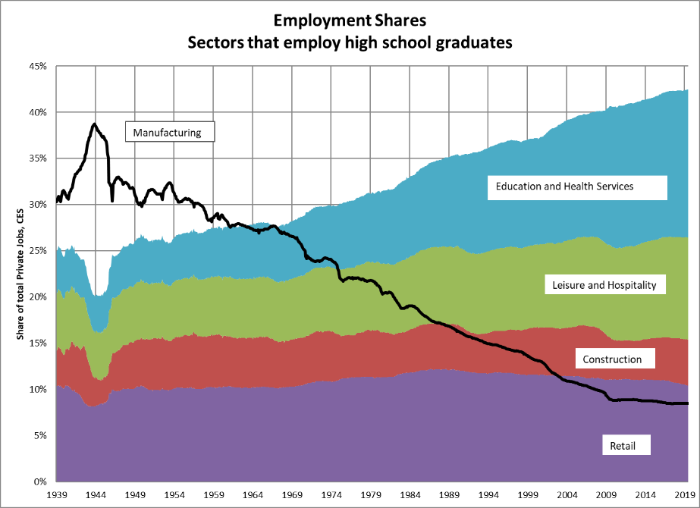

Source: FRED CES data

Figure 3 The Rise of Neurofacturing: Quality Adjusted Price for Personal Computers

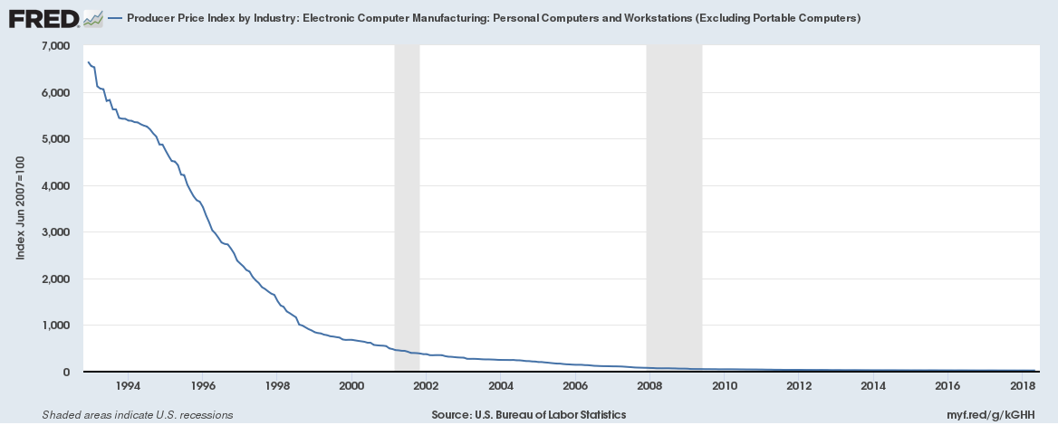

Figure 4 The Rise of Neurofacturing: Internet users

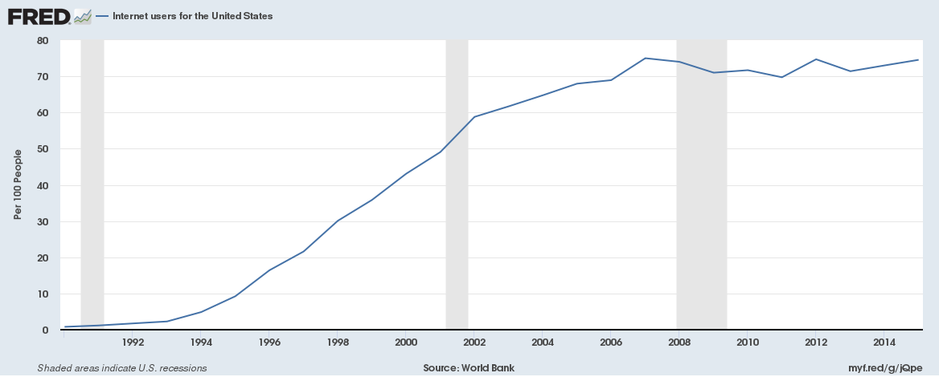

Figure 5 Net earnings as a function of effort: HS Graduates

Net Earnings

Manufacturing 2016

Leisure and Hospitality

Strawberries

0

Effort

Figure 6 Net earnings as a function of effort: Those with exceptional ability

Intellectual Services, 2016

Intellectual Services, 1980

Net Earnings

Strawberries

0

Advanced Degree Cost

Effort

Figure 7 Unemployment and Labor Force Participation Rages



Figure 8 Education Distributions, 1980 and 2016

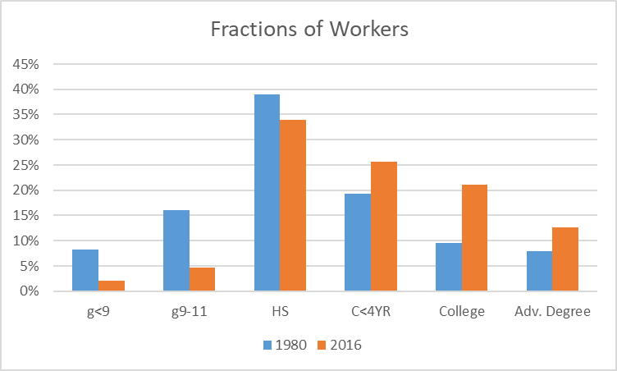

Figure 9 Male and White Fractions and Median Age

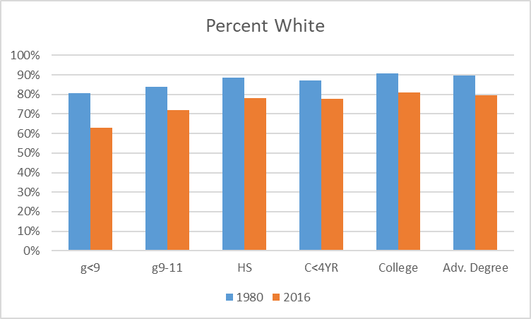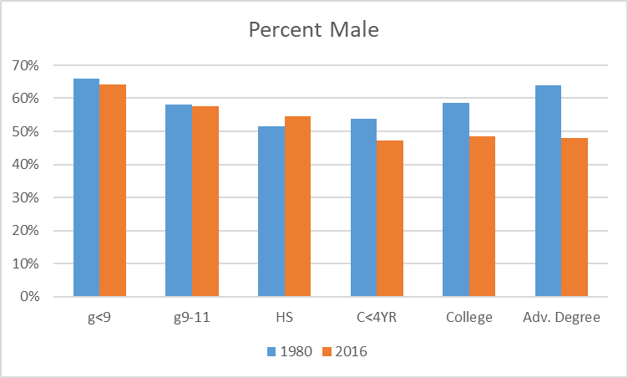

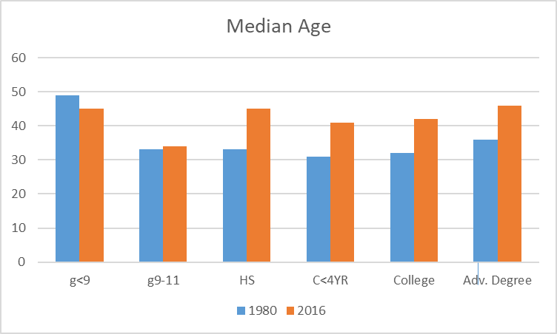

Figure 10 1980 and 2016 Age Distributions

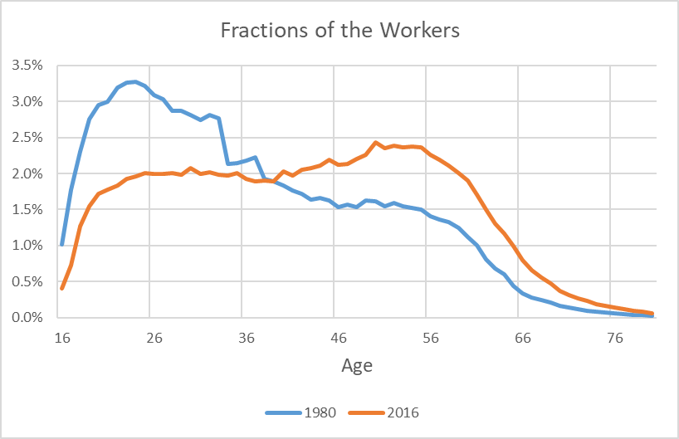

Figure 11 The Young and the Old Are Different from the Rest of Workers

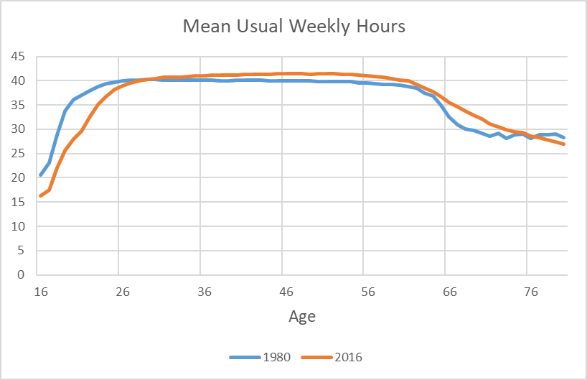

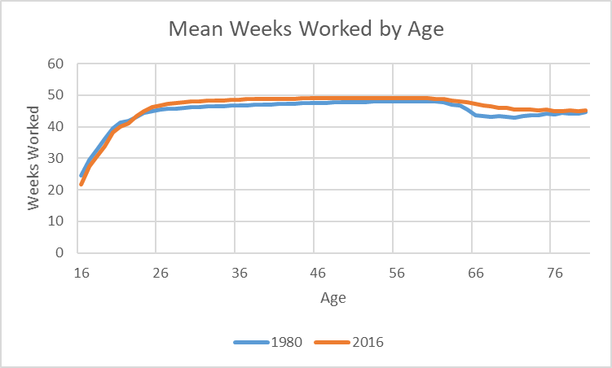

Figure 12 Fraction of Female Workers by Age

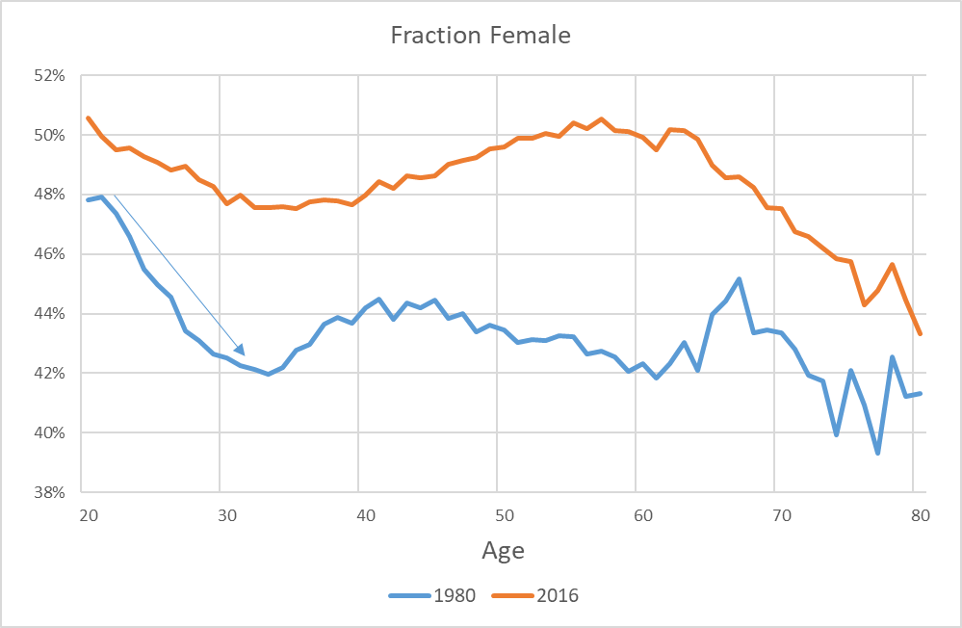

Figure 13 1980 Usual Hours per Week





Figure 14 40-hour work weeks

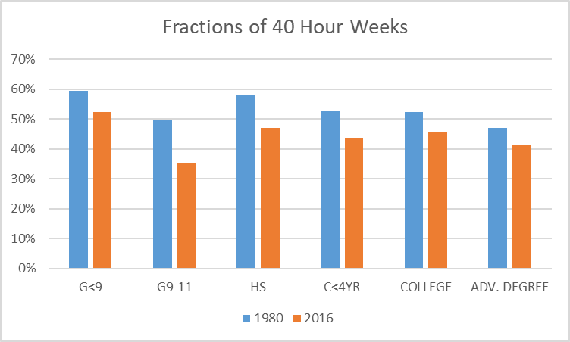

Figure 15 1980 Usual Hours Worked, G9-11, by Age

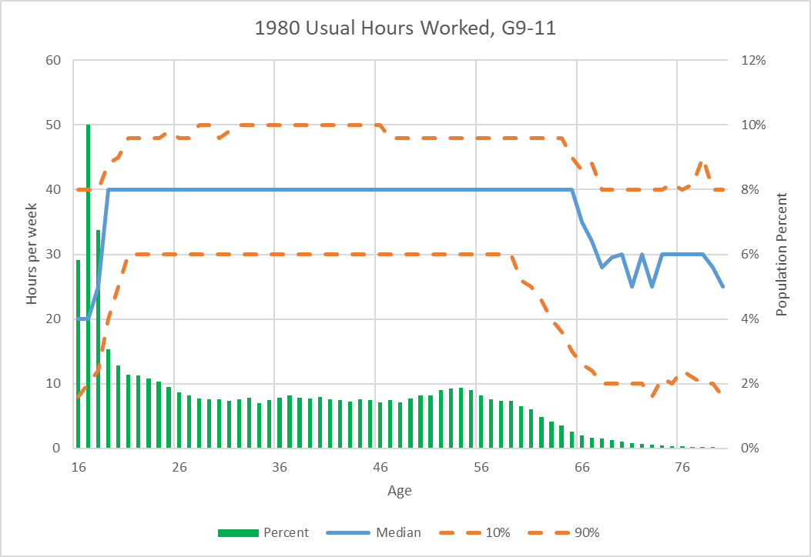

Figure 16 1980 Annual Incomes, G9-11, by Age

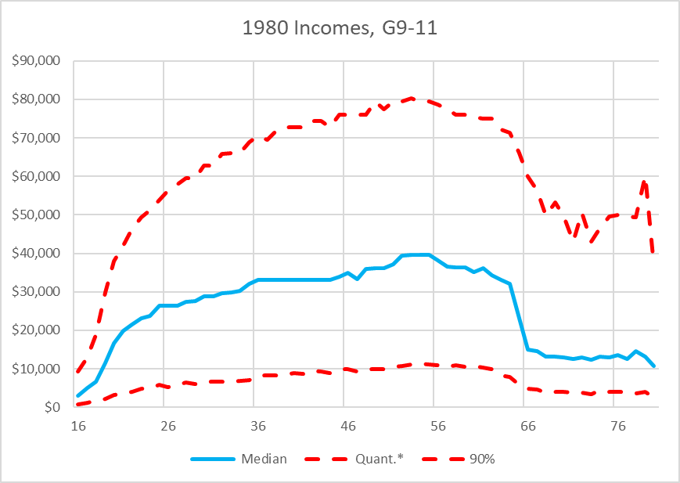

Figure 17 52 Weeks per year

Figure 18 The Effect of Age on Weeks Worked



Figure 19 1980 Mean Usual Weekly Hours

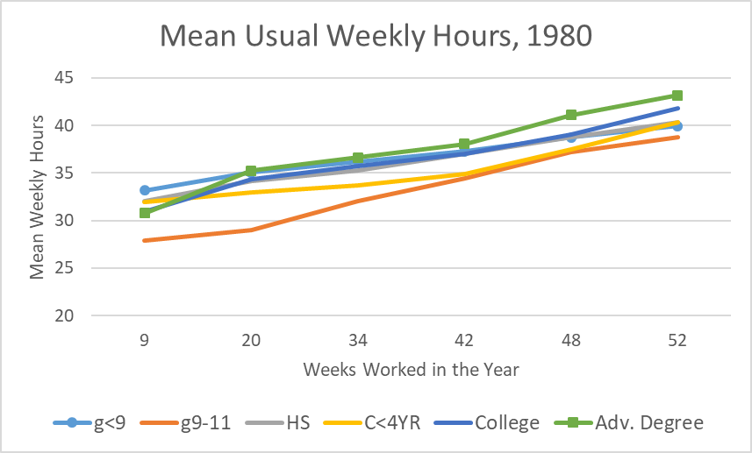

Figure 20 2016 Mean Usual Weekly Hours

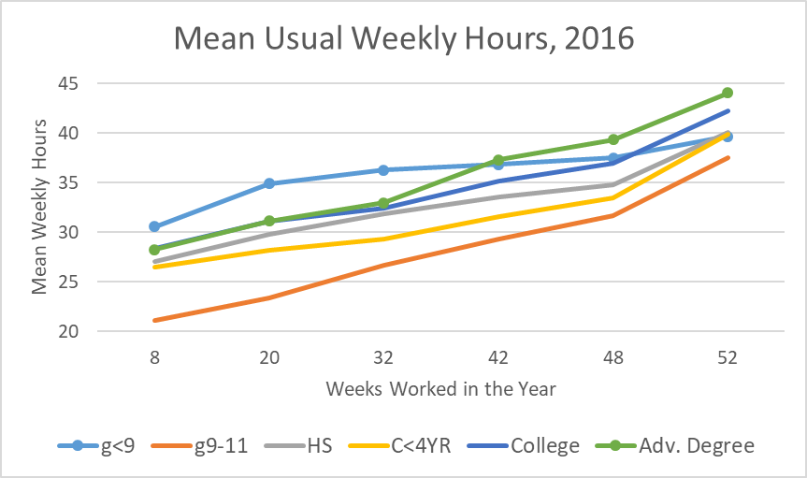

Figure 21 Hours Worked vs Age

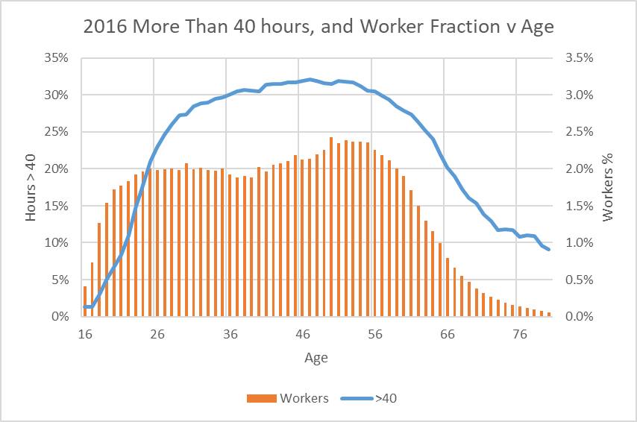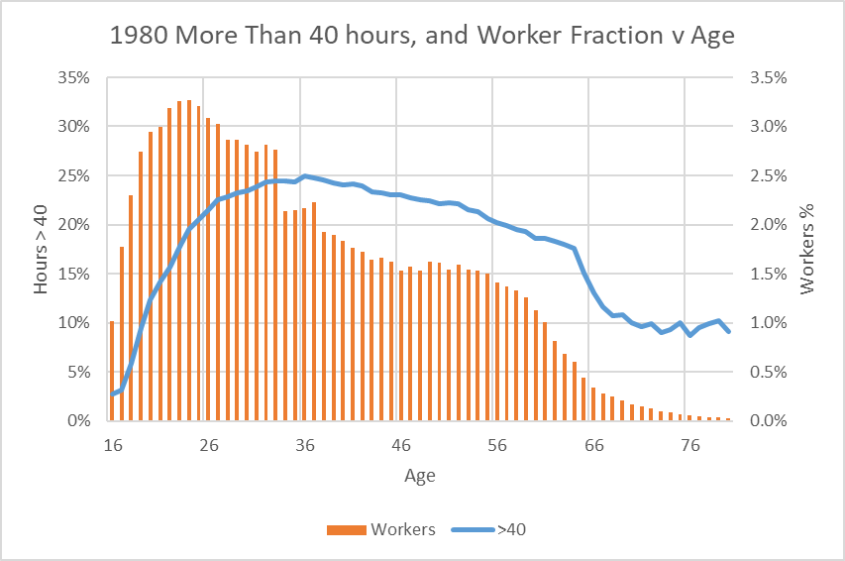

Figure 22 Weekly hours and Real Incomes

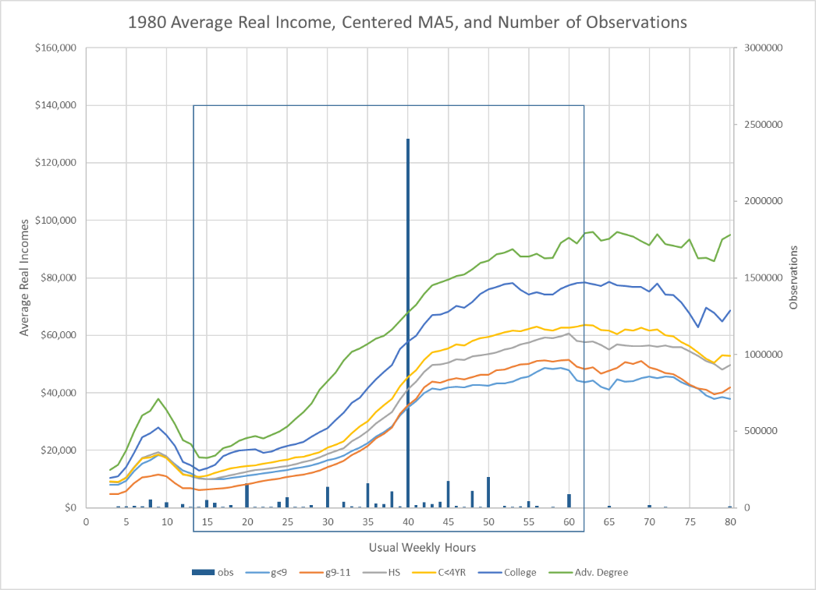

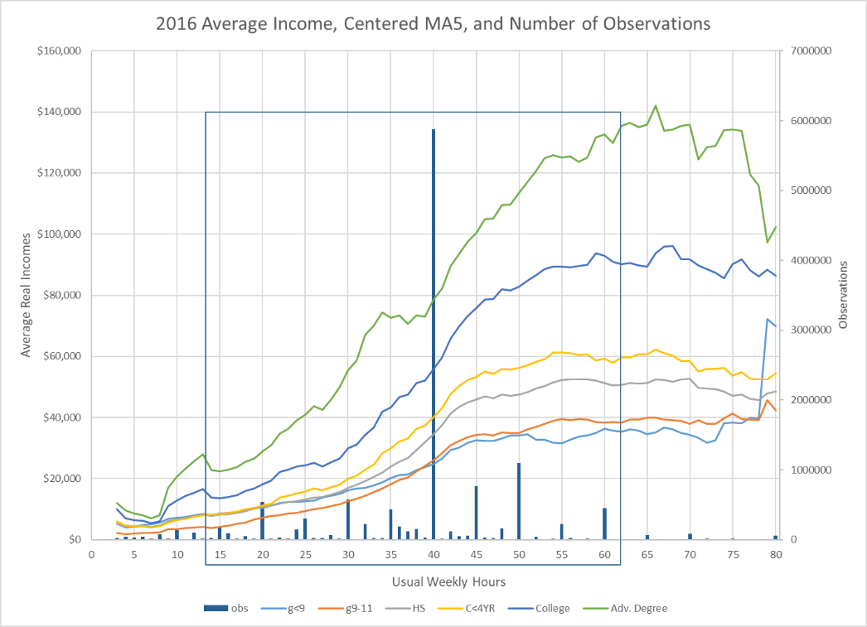

Figure 23 Real Incomes as a function of age

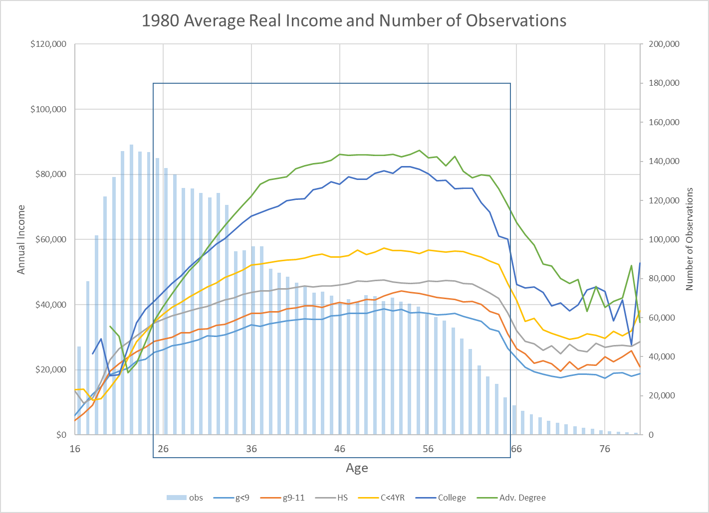

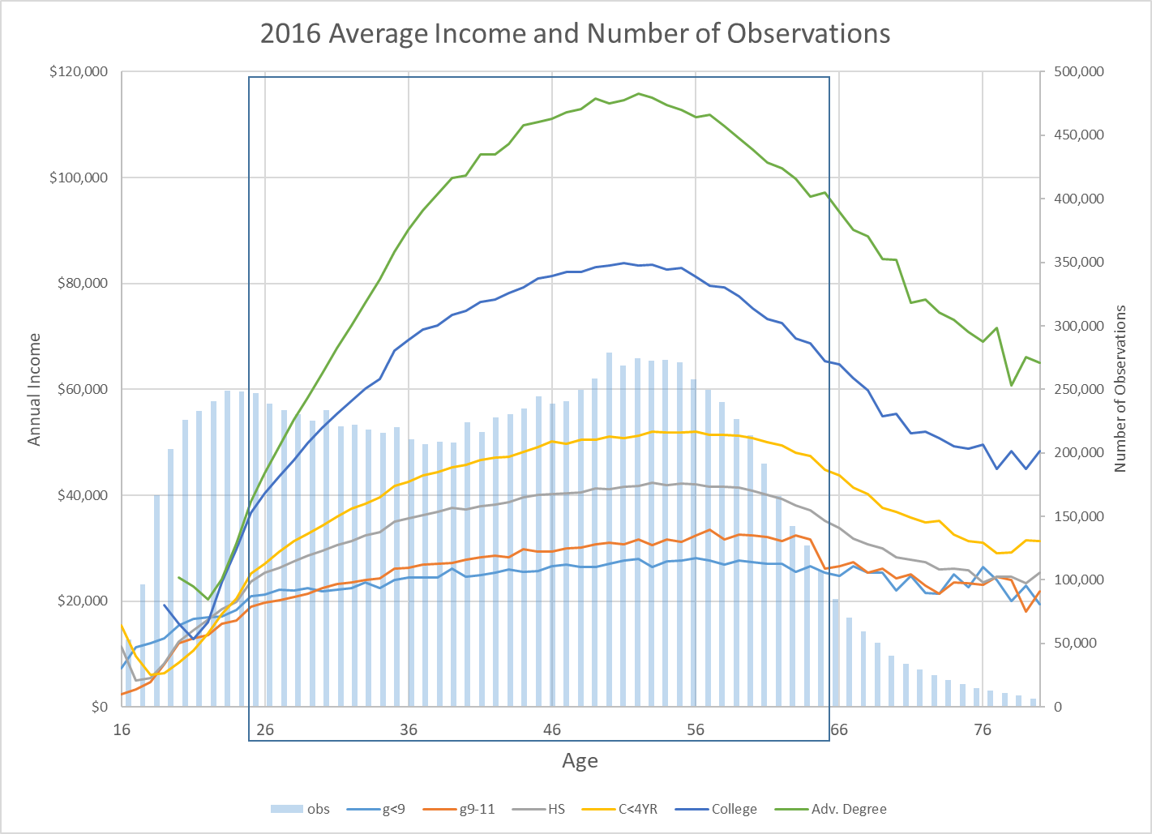

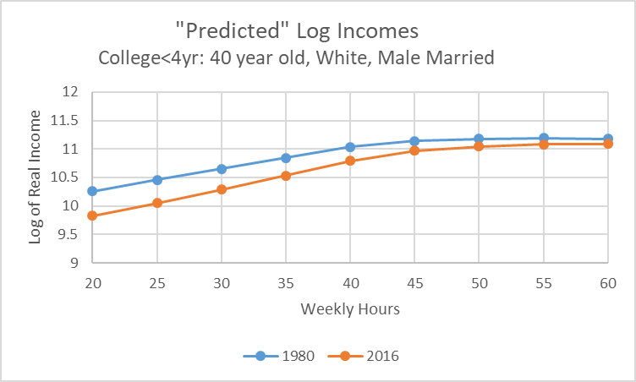Figure 24 Effect of Weekly Hours on Predicted Log Incomes

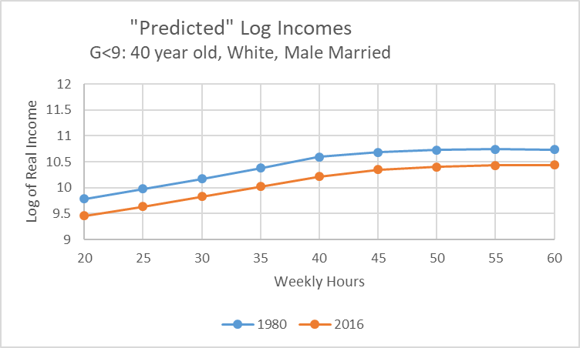

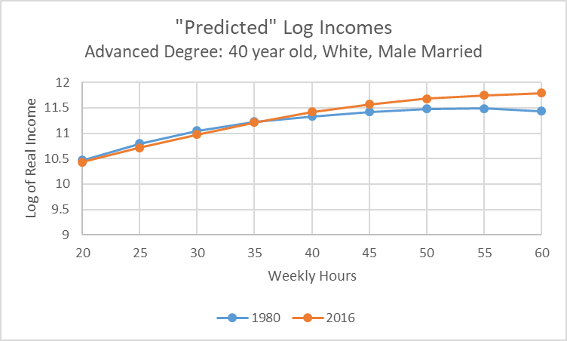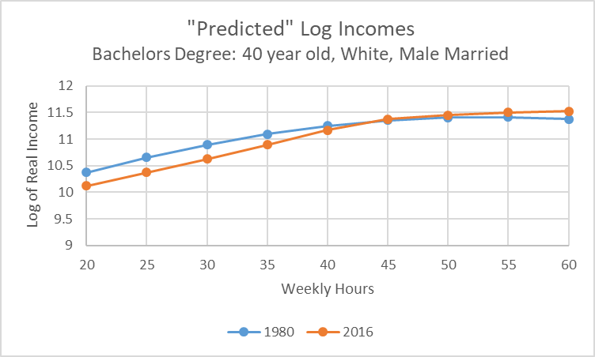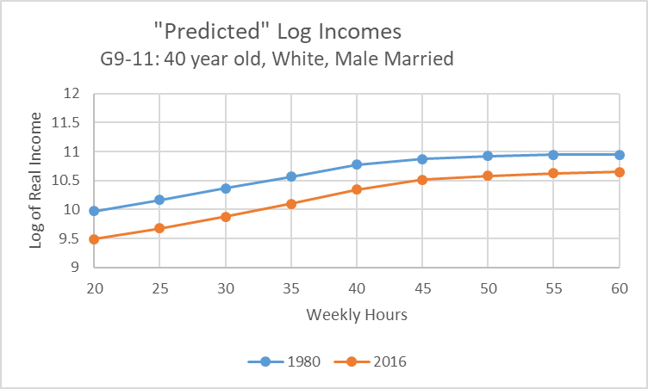

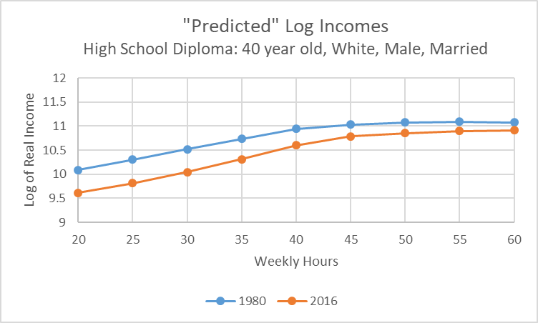

Figure 25 Rewards for Hours Different from 40

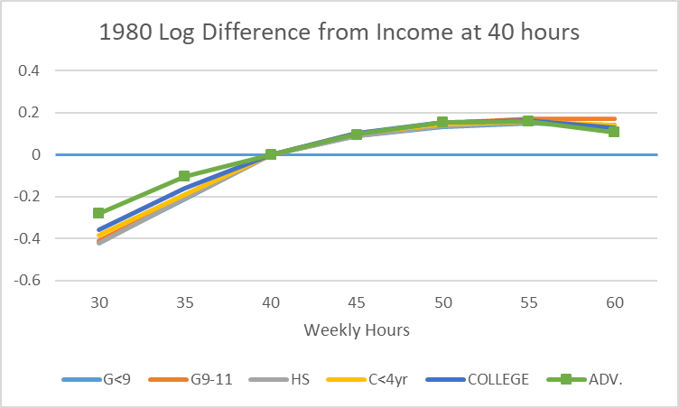

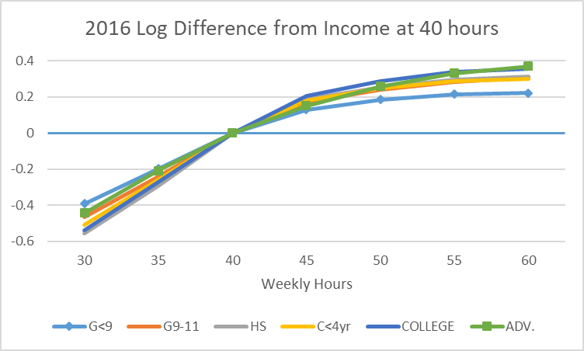

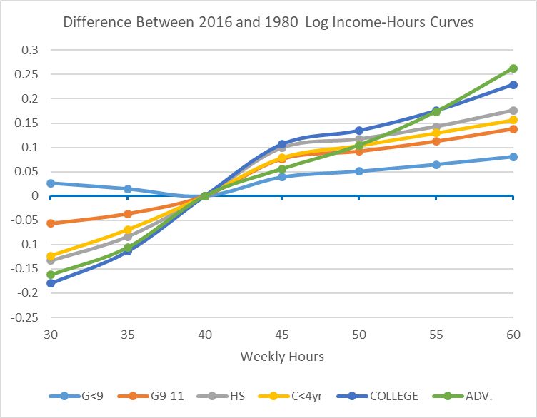

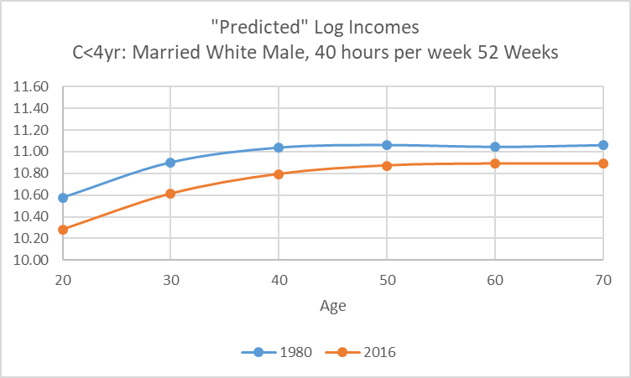Figure 26 Predicted Log Incomes as a function of Age

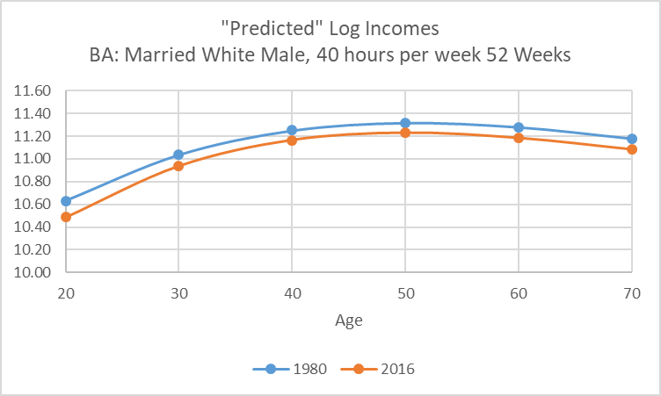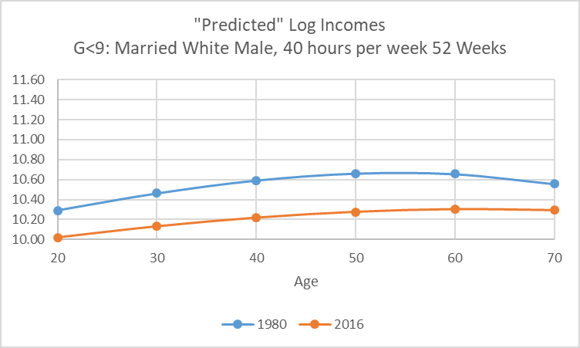

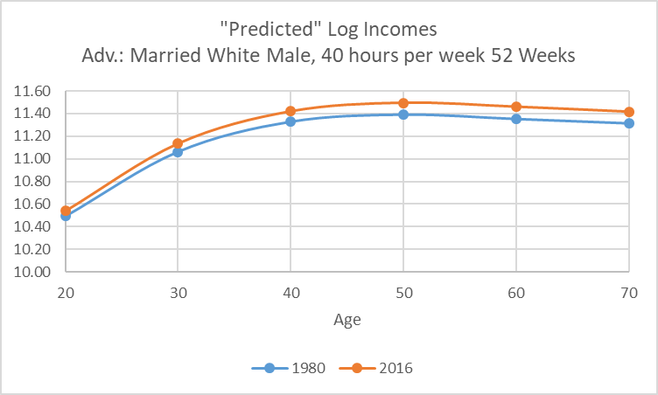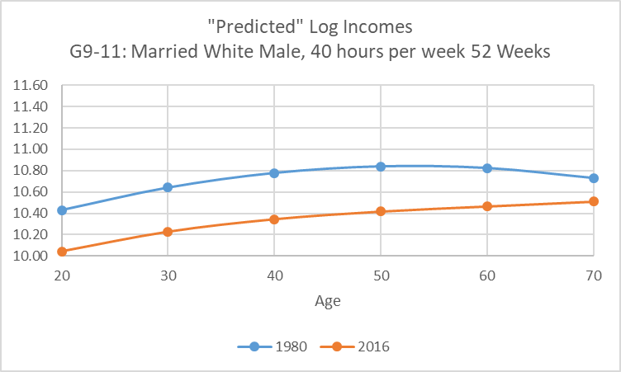



Figure 27 Effects of Weeks Worked on Predicted Log Income

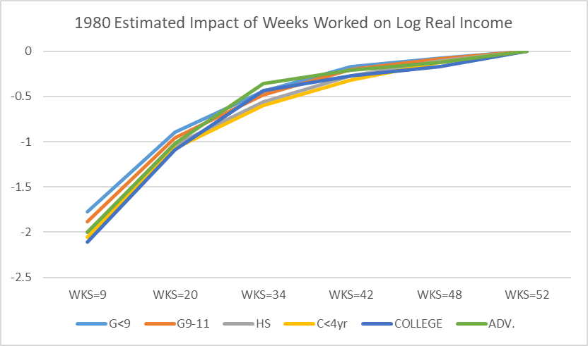

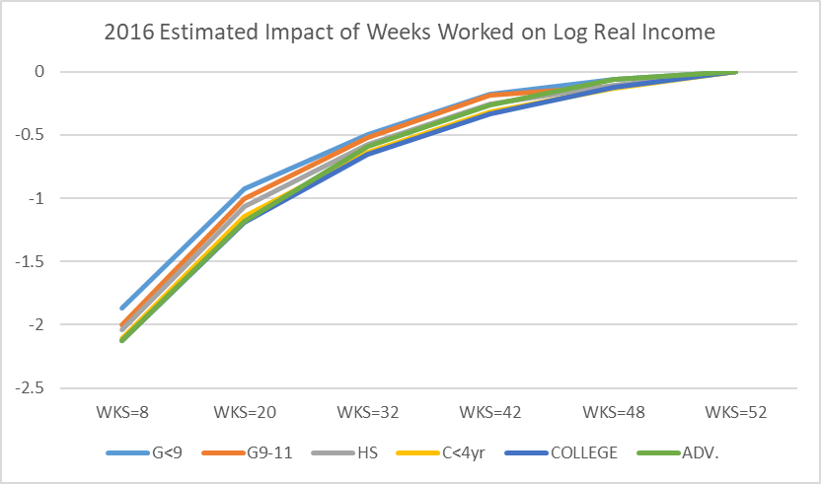

Figure 28 Male, White and Married Effects on Log Real Income

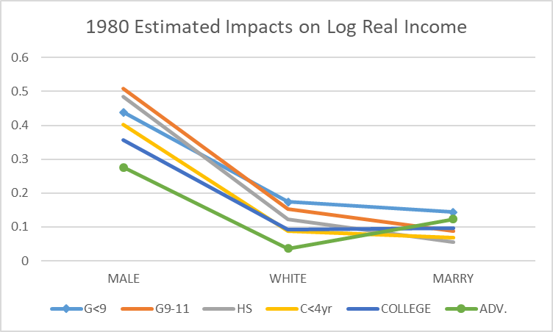

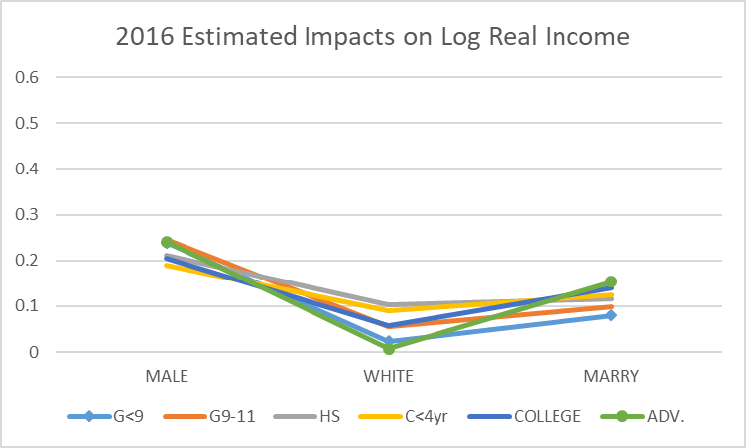

Figure 29 10th, 50th and 90th Percentiles of Usual Hours Worked

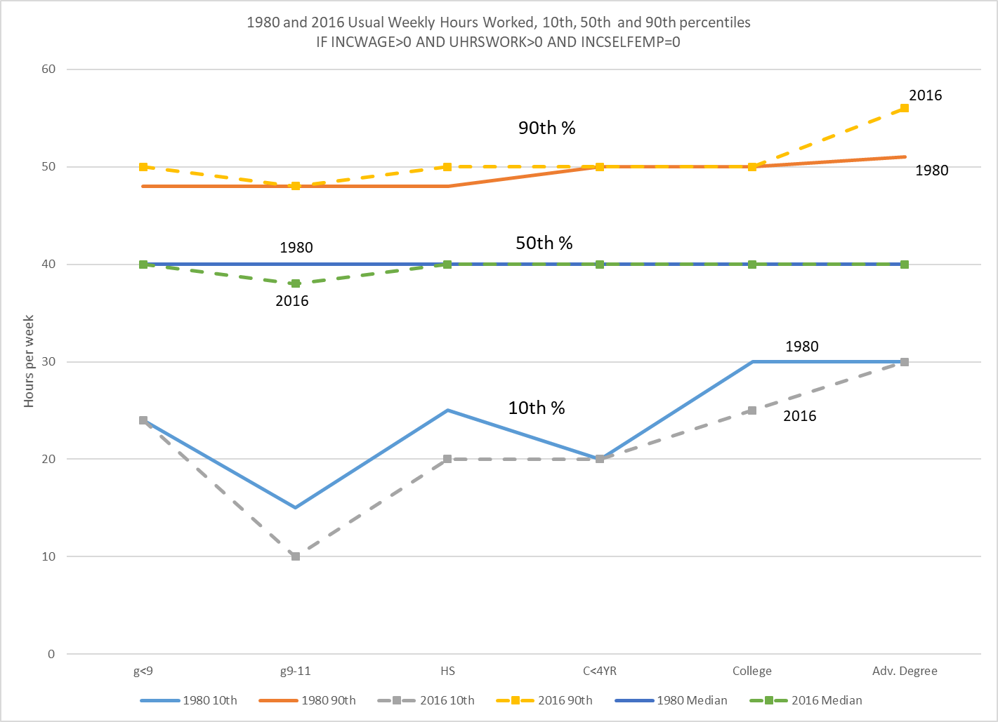

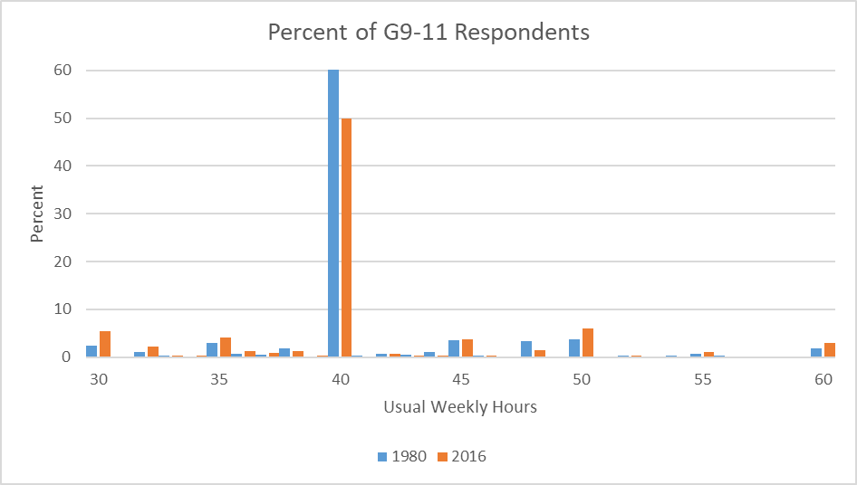Figure 30 1980 and 2016 Distributions of Usual Hours Worked, 24<AGE<65

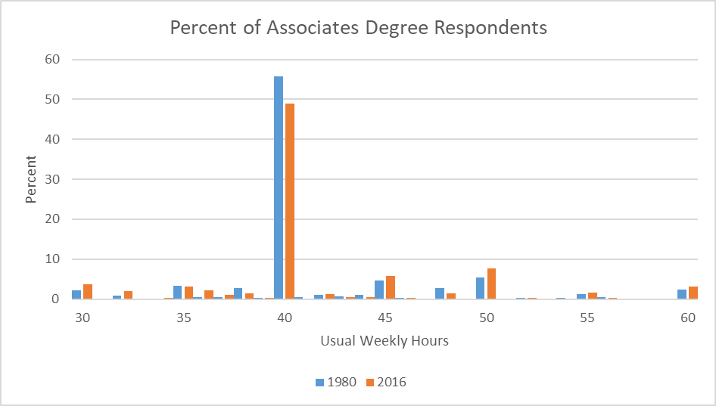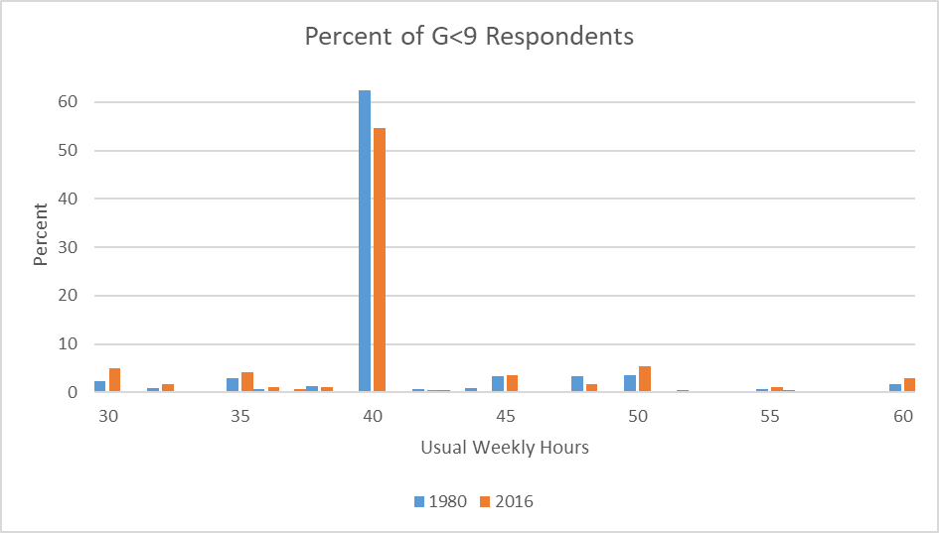

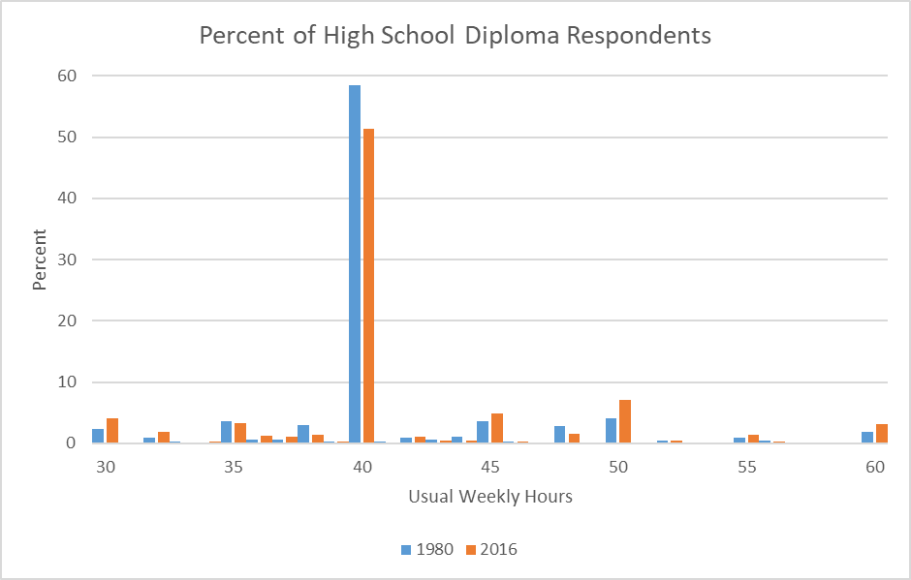

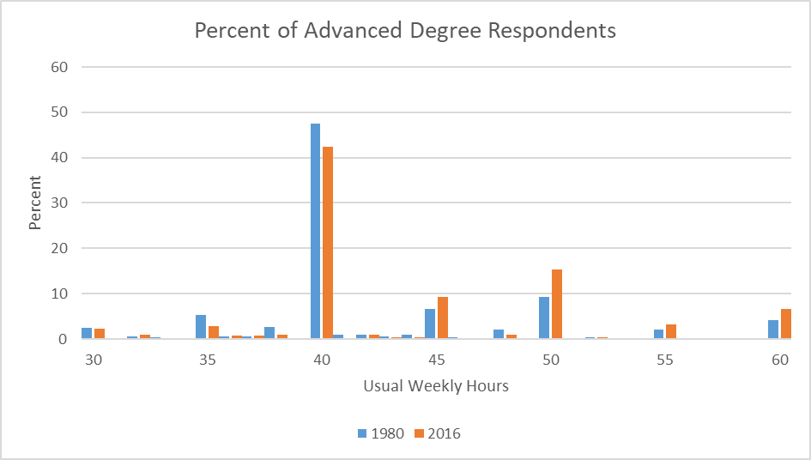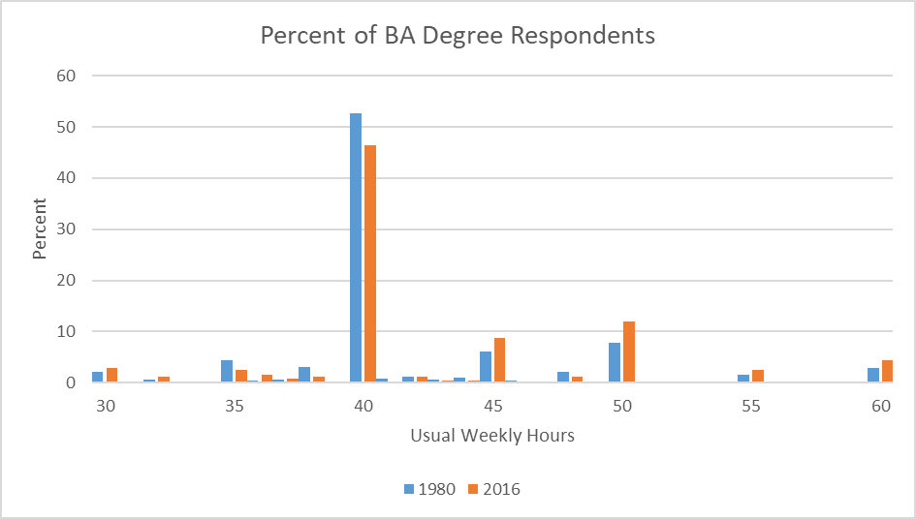

1. * **Fuentes**: Instituto de Economía, Pontificia Universidad Católica de Chile. Avenida Vicuna Mackena 4860, Santiago, Chile. **Leamer** (Corresponding Author): John E. Anderson Graduate School of Management, University of California, Los Angeles, 405 Hilgard Avenue, CA 90095, United States
2.
3. For a large summary of stylized facts see Acemoglu and Autor (2011).
4. See Raff and Summers (1987).
5. A more complete model would allow high effort choices to be constrained by higher capital rental charges because of greater rates of depreciation. For example, car rental rates depend on days of use and also miles driven thus encouraging renters not to drive the car all the time. For taxis rented by the day but not the mile, drivers naturally opt for long hours and many miles driven.
6. The variable used here from the survey is INCWAGE, which includes wages, salaries, commissions, cash bonuses, tips, and other money income received from an employer. Payments-in-kind or reimbursements for business expenses are not included.
7. All the calculations are made restricting the sample to individuals with income wage > 0, usual hours worked >0 and income from self-employed sources = 0.
8. To avoid some anomalies in the data like people reporting almost no hours worked and high-income wage we restrict the sample to hours worked from 7 to 70, we took 1% off each tail. Another alternative what we explore is to use data for people working only in the interval of 50 to 52 weeks per year, which has a median of 52 weeks.
9. An alternative way of creating continuity is a spline.
10. The changes in the estimates of the constants in the regression equations affect identically the last term in each expression since for the constant
11. There is consequently variability in the constants of the hour-based equations because of changes in the coefficients for these effects as well as the constants in the regression equations.
12. Since men in both years were paid more than women, the smallest standard error of incomes would have occurred if the workers were either all male or all female and the greatest when they were divided 50-50. The increase in the fraction of women toward 50 percent therefore increases some measures of inequality.
13. <https://countryhousereader.wordpress.com/2013/12/19/the-servant-hierarchy/>